Instructions to help edit member profile(s) for a family.

Note:
- Only the PRIMARY CONTACT of a household can edit ALL household members.
- Non-Primary household members can only update themselves.
- All “Proposed Edits” you make will need to be approved by an Administrator. This could take a few business days. Please contact the office if your changes are not reflected in your profile or your household members’ profiles within a week of submitting your changes.

Example Family used for these instructions:
- Michael (Mike) Member - Primary Contact (Husband)
- Mandy Member - Spouse (Wife)
- Matt Member - Son
- Missy Member - Daughter

Step 1: Locate your USERNAME and PASSWORD information
- Sent to you in email from church administration prior to “kickoff”
- Questions about this login information - please contact the church office.

Step 2: Log into ShelbyNext for Bloomington Living Hope Lutheran Church
- https://bloomingtonlivinghope.shelbynextchms.com

Step 3: Complete Login Screen
- Your USERNAME and PASSWORD into the login page
- Click <LOGIN>

Remember: The Primary Contact’s User Name / Password allows editing to the entire household.

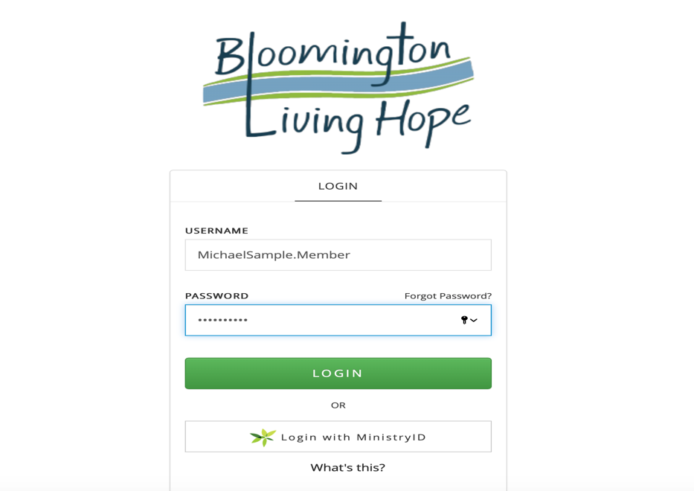

Step 4: Review your personal Profile page(s)

You will now be able to view and edit your profile. Primary Contact can also view and edit profiles for all household members.
- Our sample Primary Contact is “Mike Member”
- Your Name will appear in the upper portion of the screen (where “Mike’s” name is showing in the below sample)
- Your Initials will appear in the upper right hand corner (where you see “MM” in the below sample)

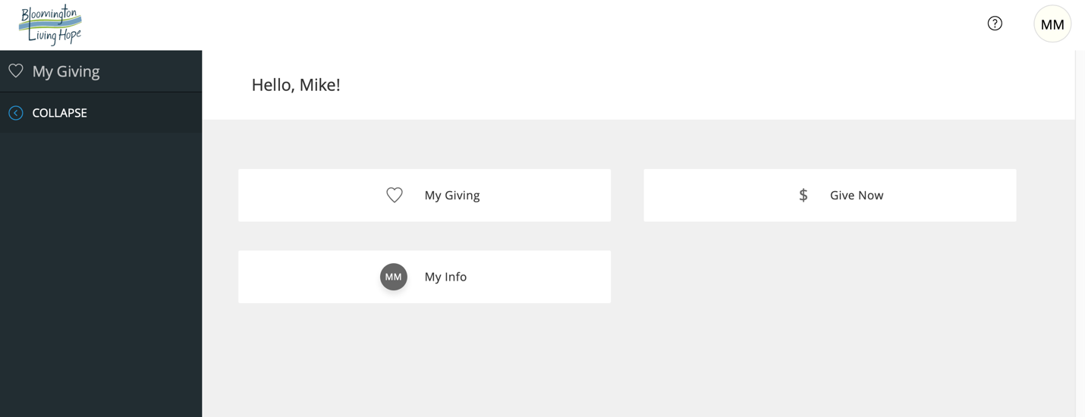

Step 5: Access your Profile information by clicking on either profile button:
- “My Info” box in the main screen
- Your “Initial Circle” in the upper right hand corner.

Step 6: Review your own Profile details for accuracy:
- This is the information the church currently has for you and your family members.
- Please review to see where information needs to be updated.
- Click on the <EDIT> tab to edit your profile information

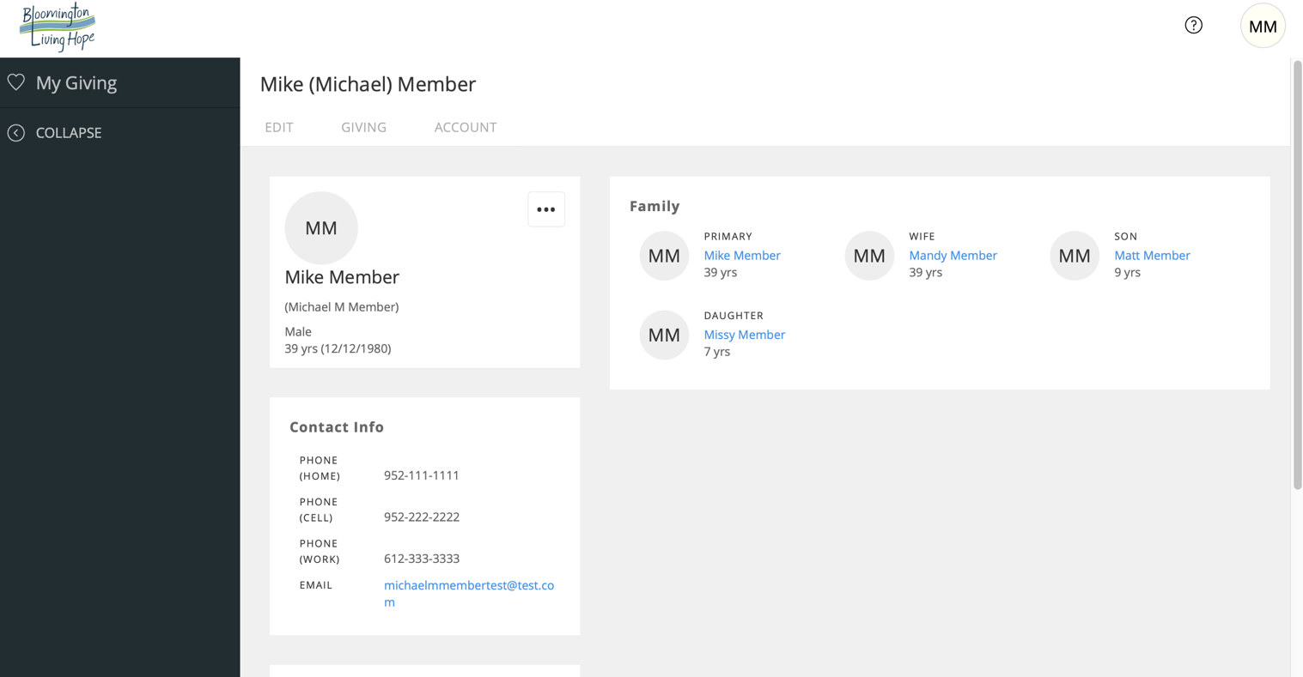
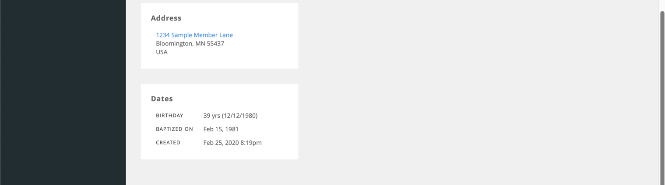

Step 7: Edit any profile fields that need to be updated
- Any field not in “grey” can be edited and saved by you
- You can use the scroll at the far right to scroll down the screen
- Select <SAVE> at the bottom of the screen to save your changes
- NOTE: Any other information that cannot be edited by you, can be changed by contacting the church office.
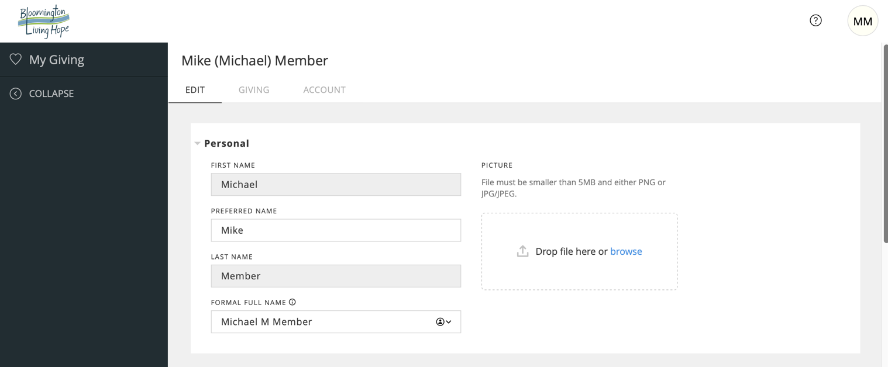
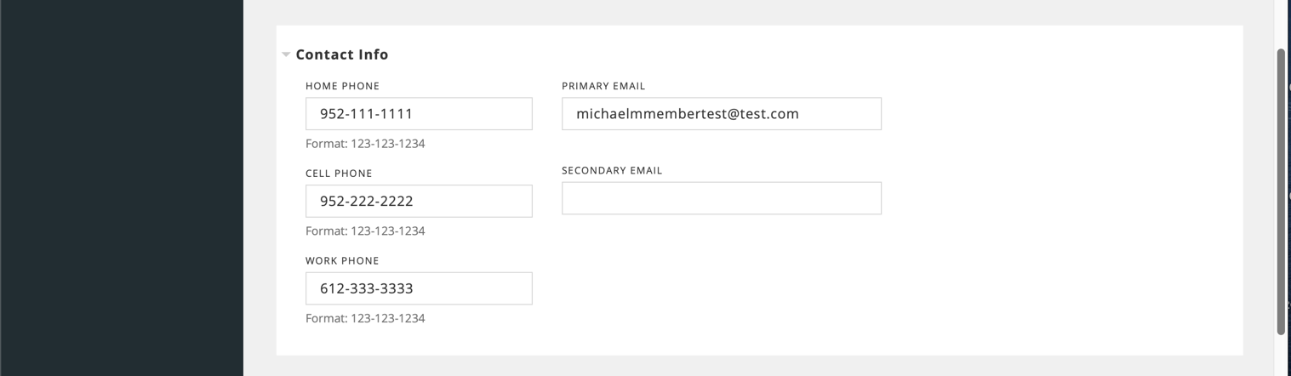
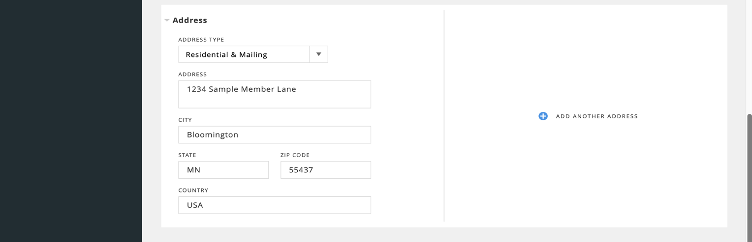
Step 8: Address and Home Phone Number changes will prompt an additional message.
- This message will ask whether you want this change to apply to ALL of your household members.
- If you want to apply the changes to ALL members of your family, press <UPDATE FAMILY>.

Example: Edited the Home Phone Number

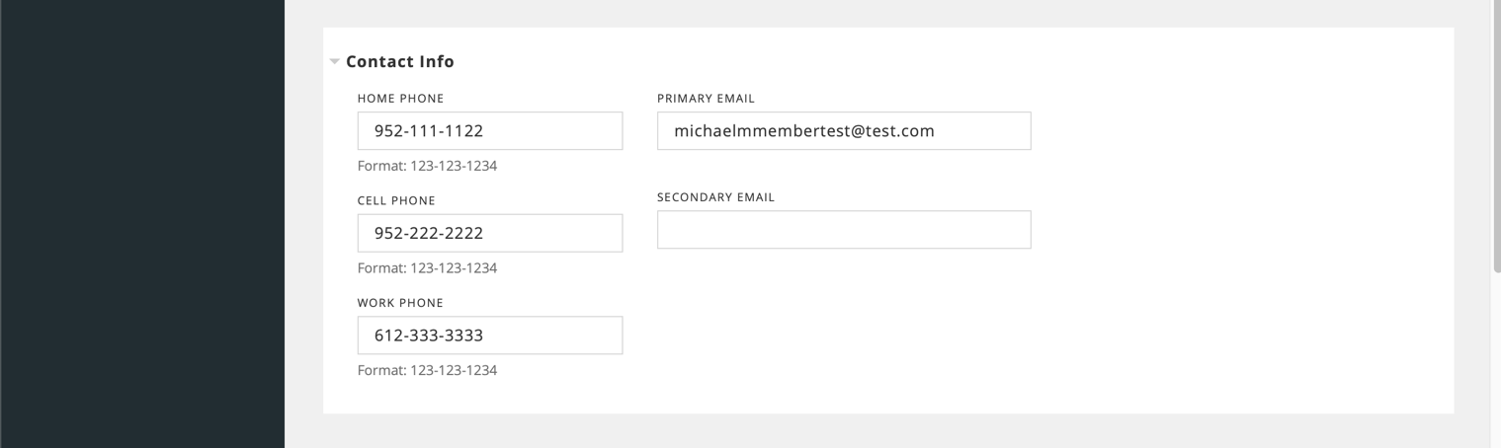

When you click <SAVE> on your edited home phone number or address, you will see the following message:
- Click <UPDATE FAMILY> to apply changes to your whole household.
- Click <THIS RECORD ONLY> to apply changes only to your single profile.

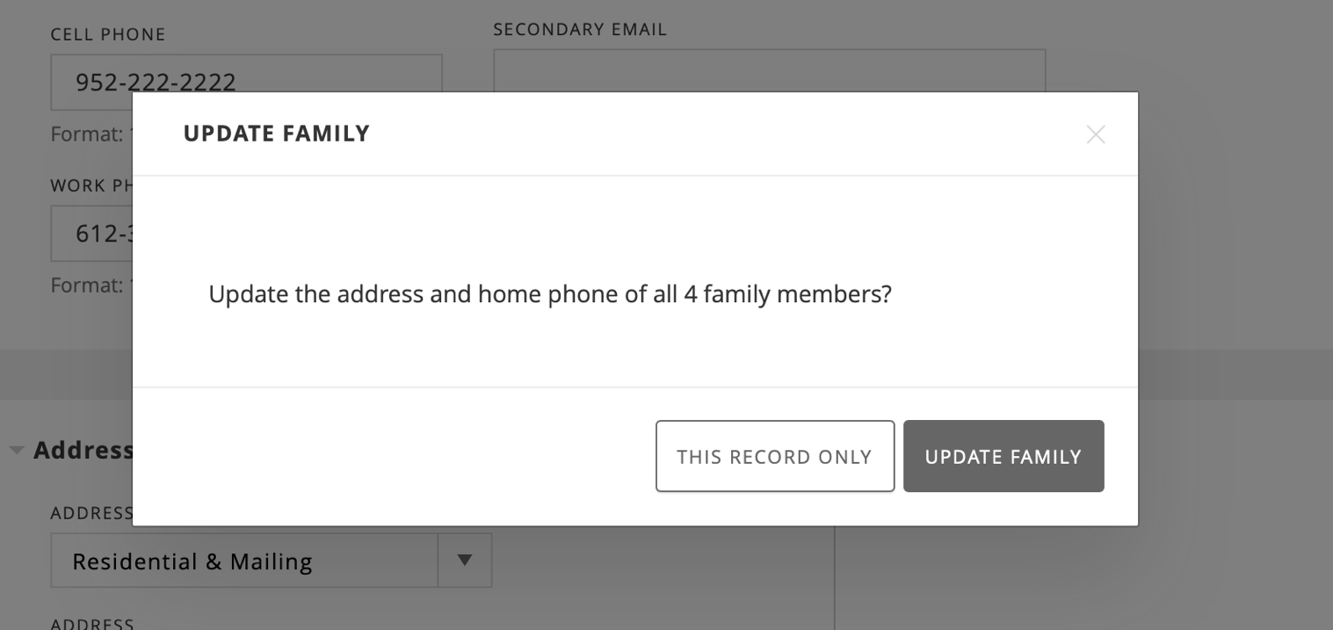

Step 9: If you make edits and click <SAVE>, you will see the following “PROPOSE EDITS” message before the changes are submitted:
- Just type “Member Update”
- Click <Propose Edits>
- These edits will take effect once the administrator approves the request
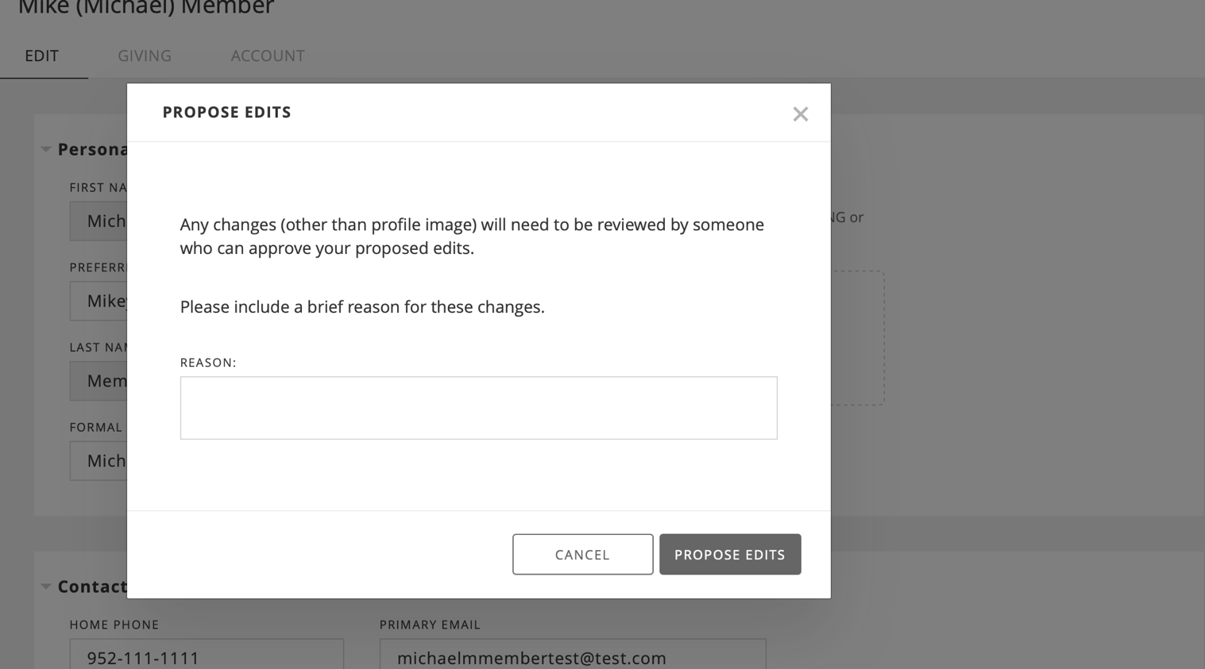

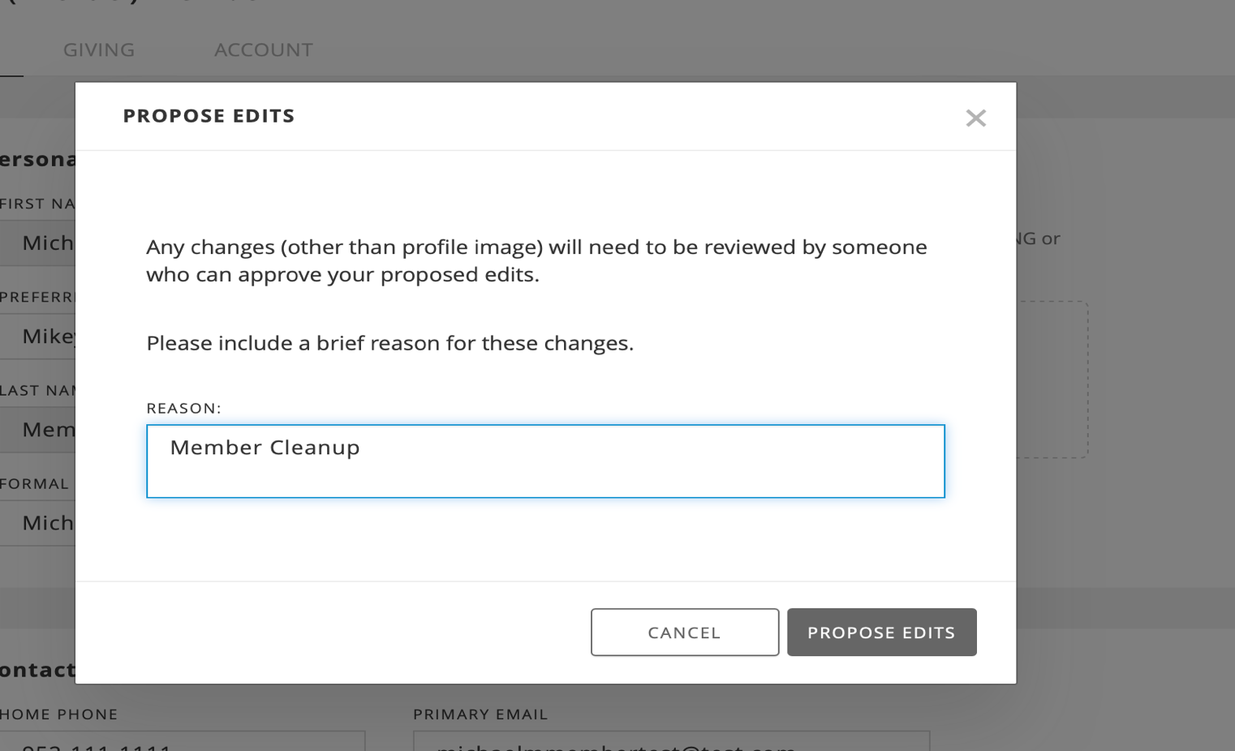

Step 10: Changes will NOT take effect until Administrator in Church Office approves:
- It could take a few business days
- Please notify church office if your changes have not been updated within 1 week.

Step 11: Updating your other Family Members’ Profiles:
- The Primary Contact will see all members of the family in his / her profile page.
- From here, the Primary Contact can navigate to each person’s profile page to edit any additional details that need to be updated.
- You can click on the person’s name (e.g. Mandy Member) to view and edit that person’s profile

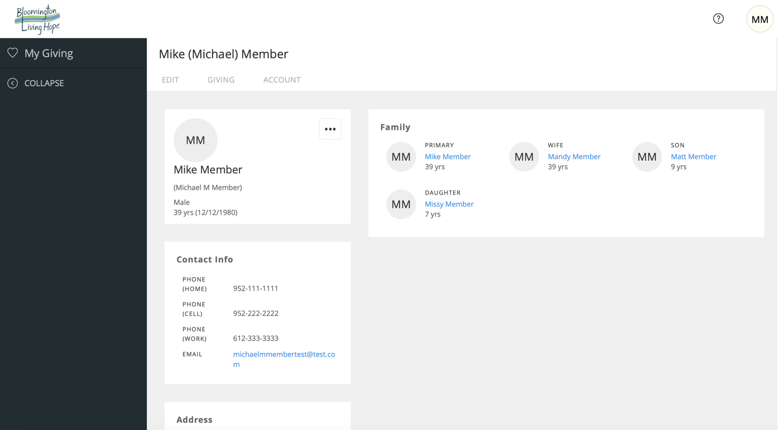

Step 11: Review each family members’ information page, press <EDIT> if you see changes that are needed:
- Review the details on the page for each family member (example: Mandy Member).
- If changes are needed, you are click on the <EDIT> tab to edit the information for that person.

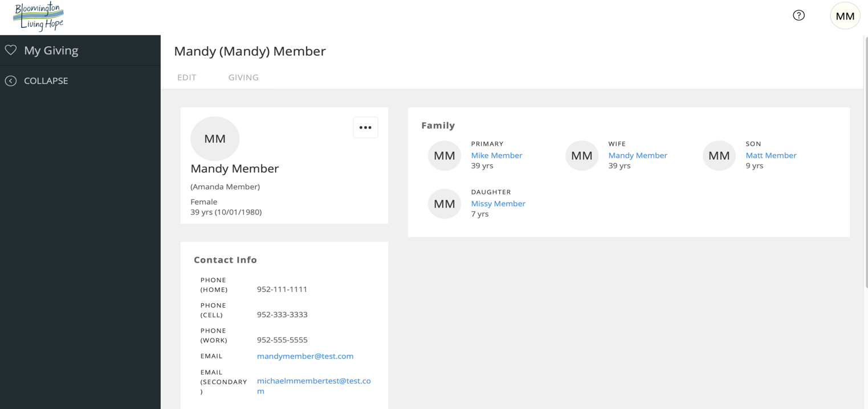

GO BACK TO STEPS 7 - STEPS 10 (Follow the same steps for each family member’s profile):
- Validate information in all fields; Make Edits to any fields that need changes
- Hit <SAVE>

