Instructions for Online Giving

Note:
- You must set up your MINISTRY ID before continuing with these Online Giving steps
- See “INSTRUCTIONS FOR SETTING UP MINISTRY ID FOR LOGIN” instructions.

Example Family used for these instructions:
- Michael (Mike) Member - Primary Contact (Husband)

Step 1: Log into ShelbyNext for Bloomington Living Hope Lutheran Church
- https://bloomingtonlivinghope.shelbynextchms.com

Step 2: Complete Login Screen
- You will use your Ministry ID to log into ShelbyNext (Computer and Phone App)
- Always select <Login with MinistryID>

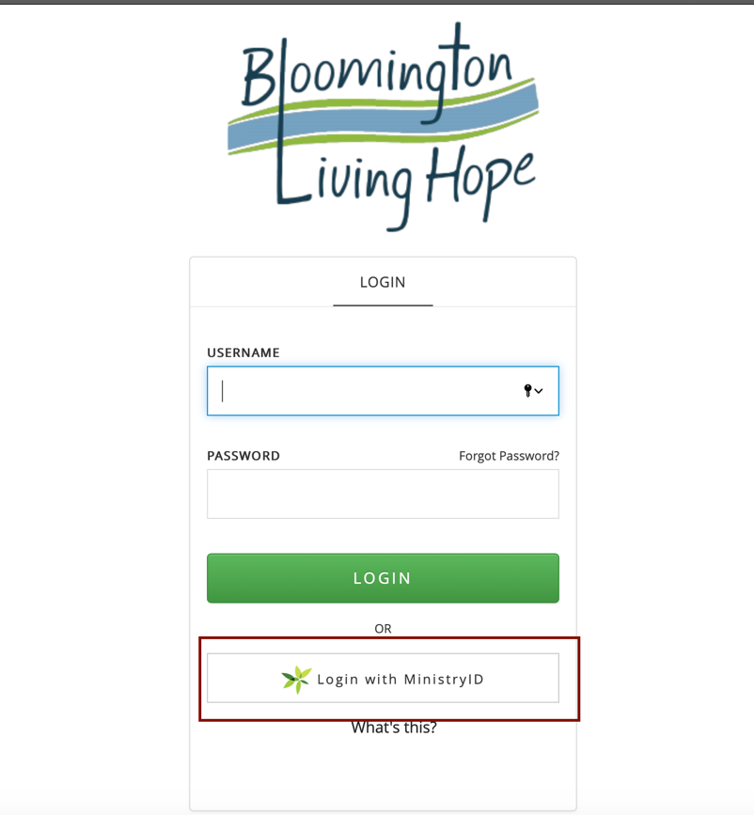

Step 3: Complete MINISTRY ID Login Screen
- Use your Ministry ID (Email + Password)
- Select Login

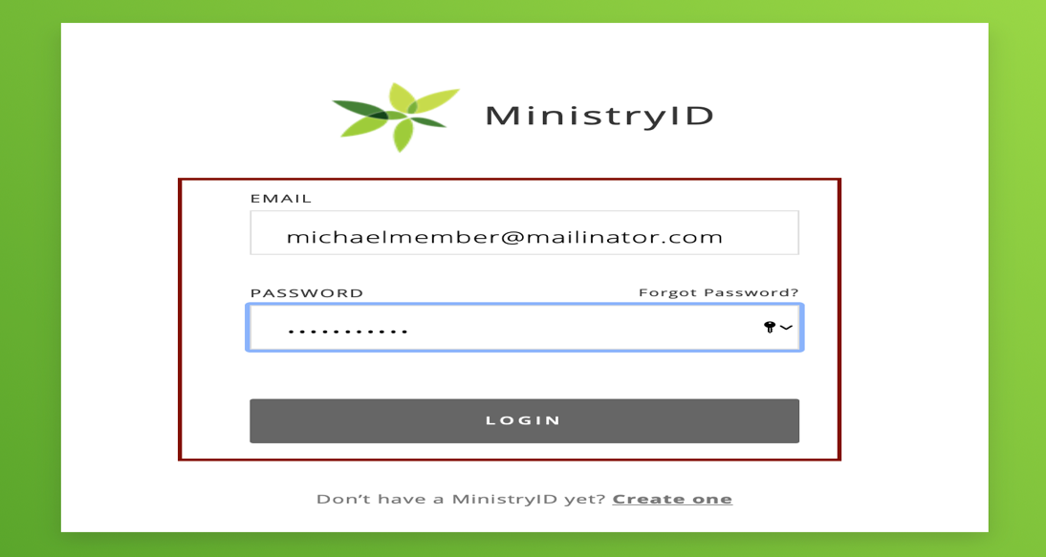

Step 4: Click on the <$ Give Now> box
- You are now being directed to the Giving features of ShelbyNext
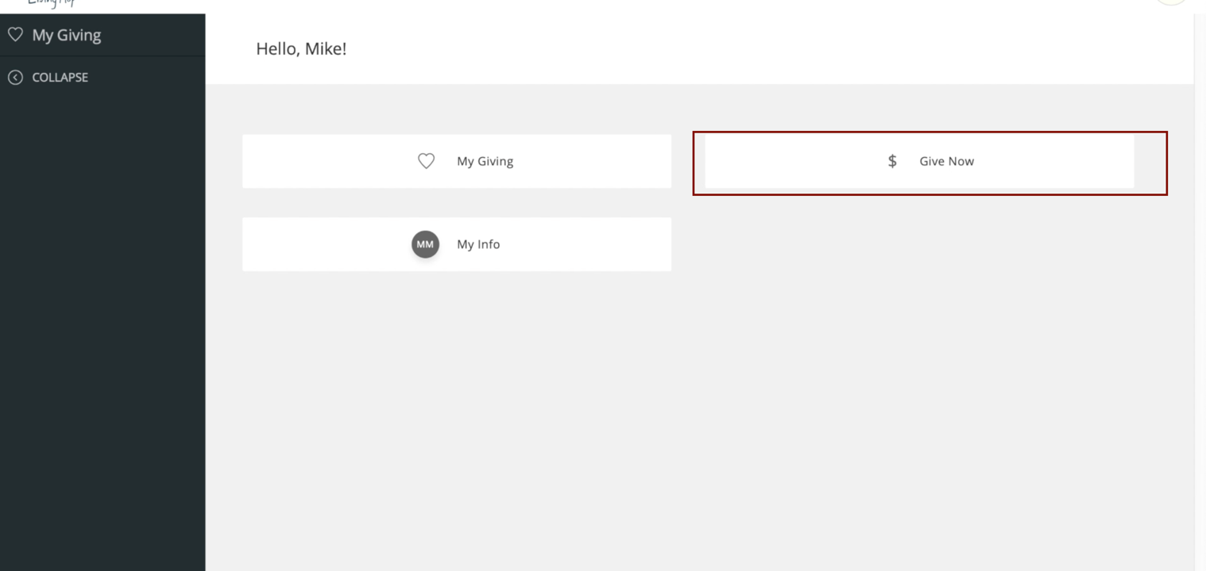

Step 5: $ Give Now
- You are now at the “Giving Page”
- This is the page where you can set up your information for
  - One Time Giving
  - Recurring Giving
  - Set up Credit Card or Bank Information

- IMPORTANT NOTE: The steps below outline setting up a “RECURRING” Online Giving Amount. If you are doing a one-time donation, follow the same steps except do not select <Make this Gift Recurring>. All steps will be identical except you will not see a “Recurring Gift Details” section.

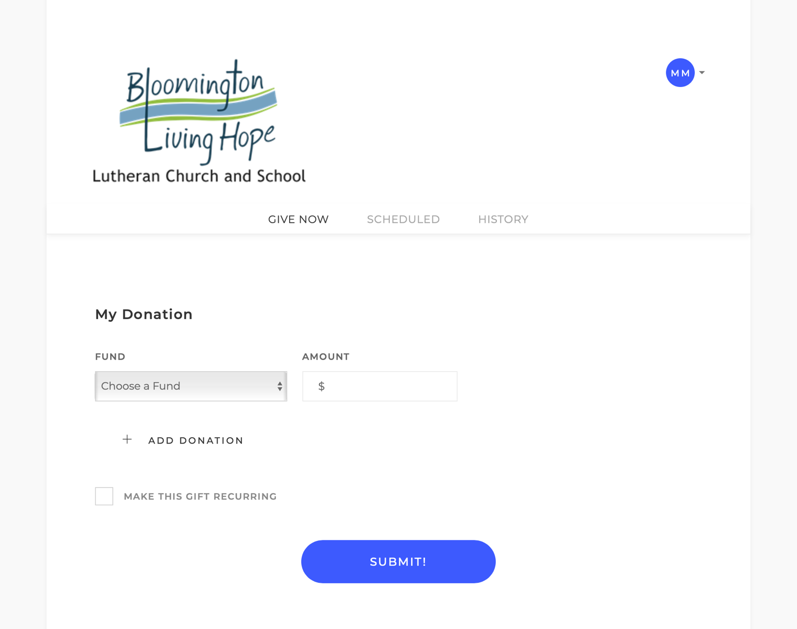

Step 6: Recurring Giving: RECURRING box (to get into Giving Setup).
- Click the box next to “MAKE THIS GIFT RECURRING”
- Recurring setup screen appears for you to complete

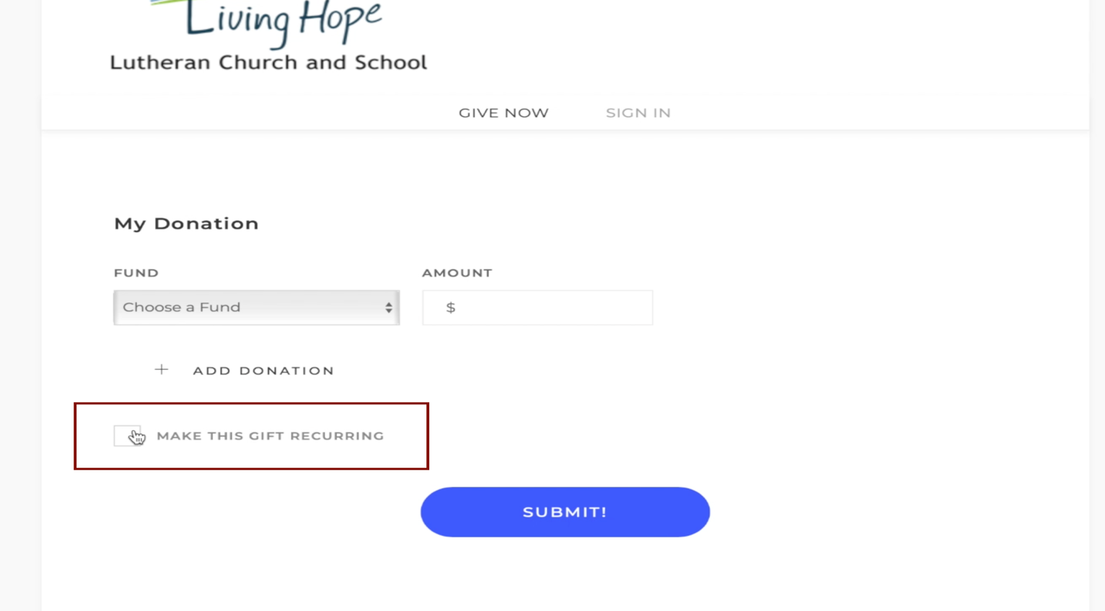

Step 6: Set up Giving Locations, Amounts, Frequency
- Click the box next to “MAKE THIS GIFT RECURRING”
- Recurring setup screen appears for you to complete
- You go through the screen and complete for your Fund location, $ Amt, and Frequency.
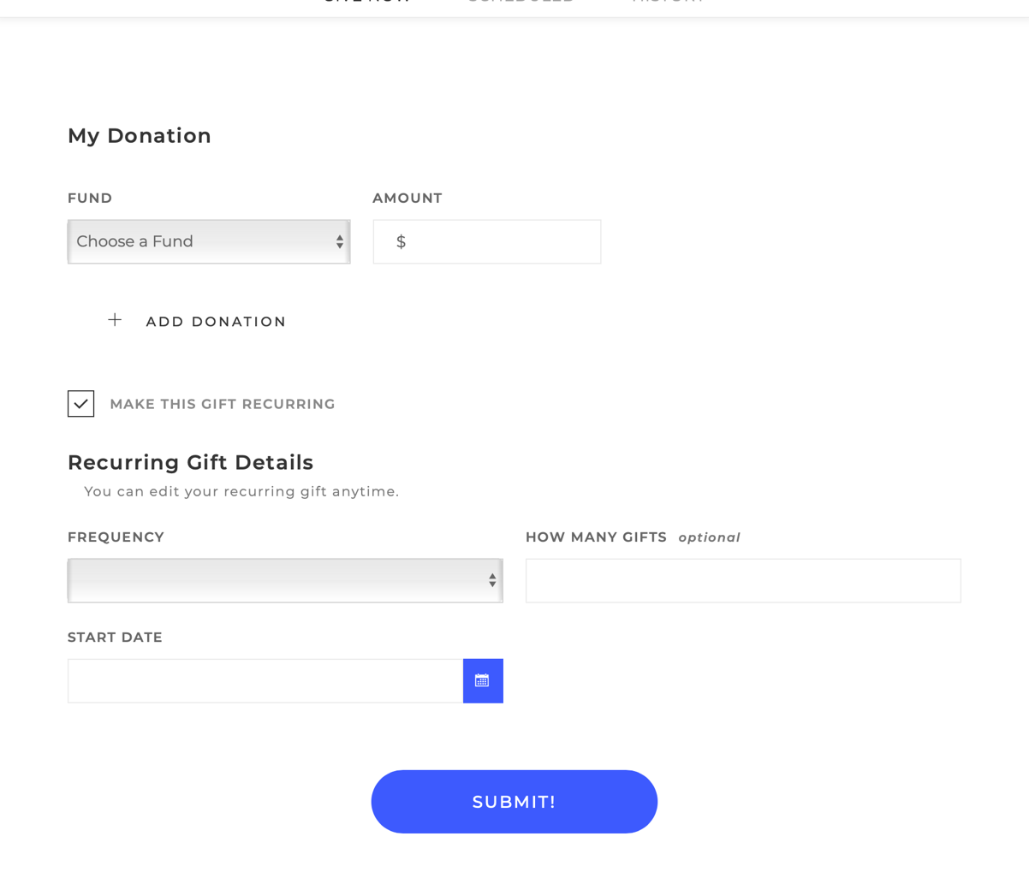

Step 7: First: Select one of the FUND allocations for your donation.
- Options:
  - General Envelope Bloomington Lutheran
  - General Envelope Living Hope
  - Build the Dream - Bloomington
  - Build the Dream - Living Hope
  - Costa Maya
  - Deficit Reduction
  - Mercy Ministry
  - Missions
- Complete Amount (e.g. $150.00)
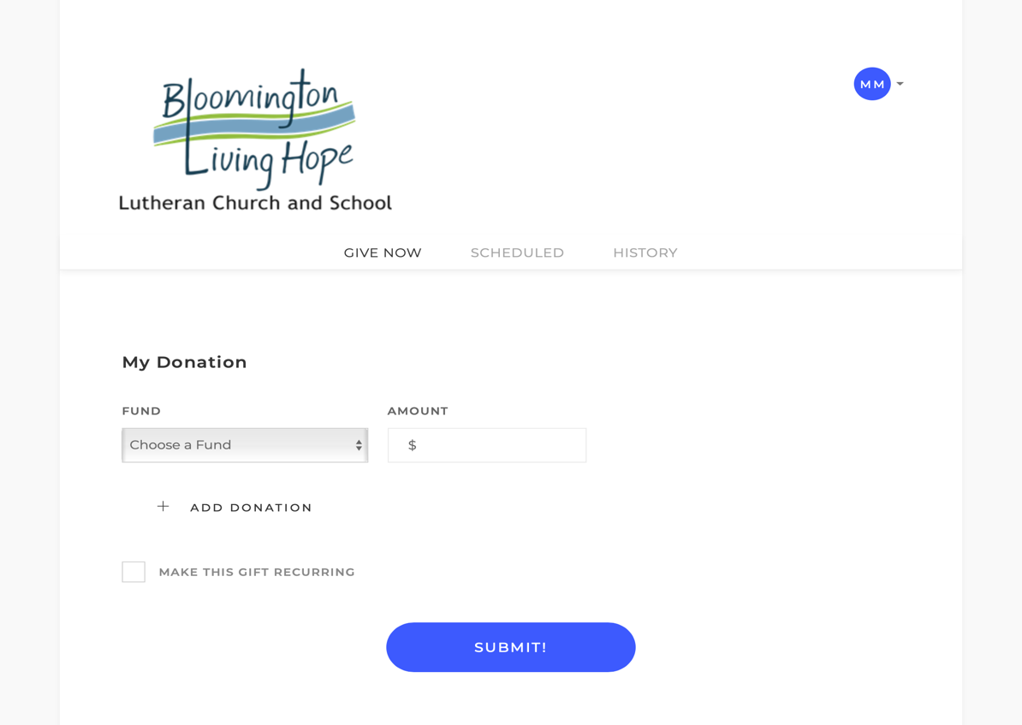
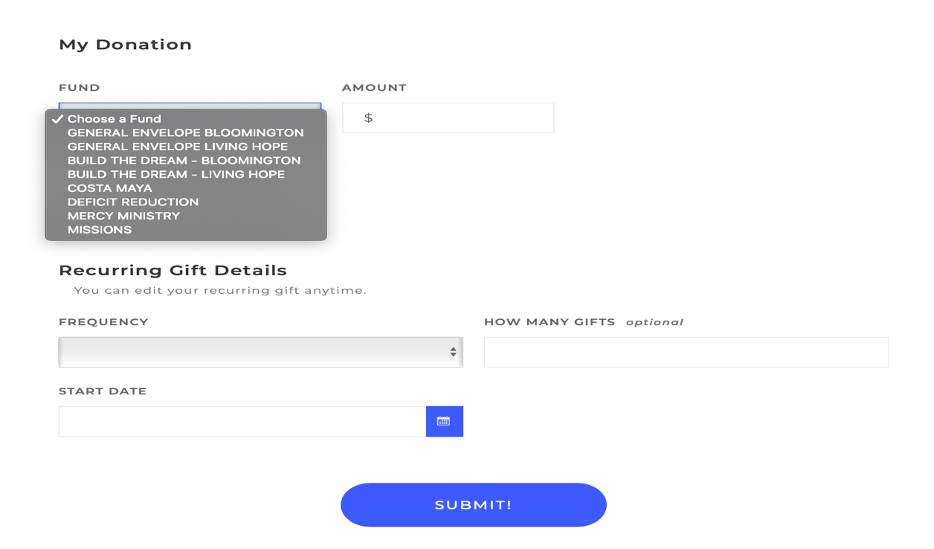

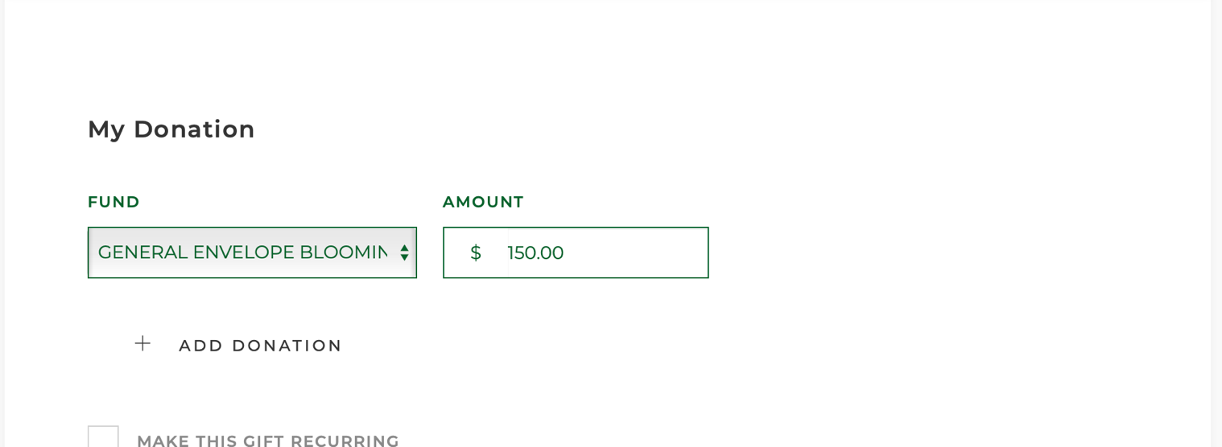

Step 8: If you wish to give to more than one Fund, select “ + Add Donation”
- Click on “+ Add Donation”
- Select “FUND” and complete “Amount” for the additional donation category.

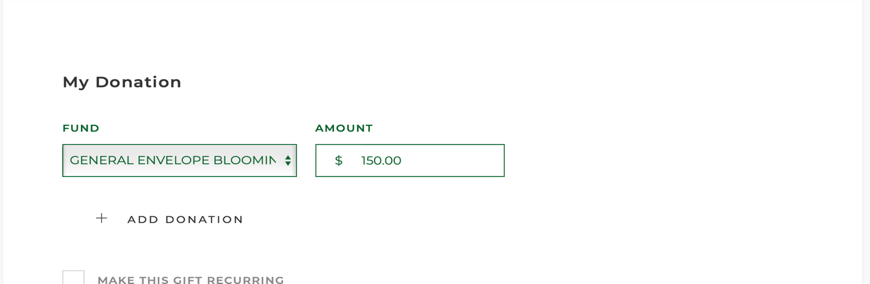

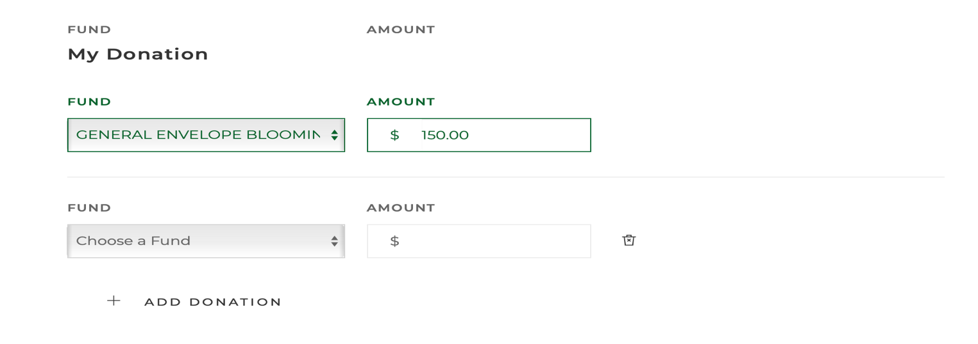

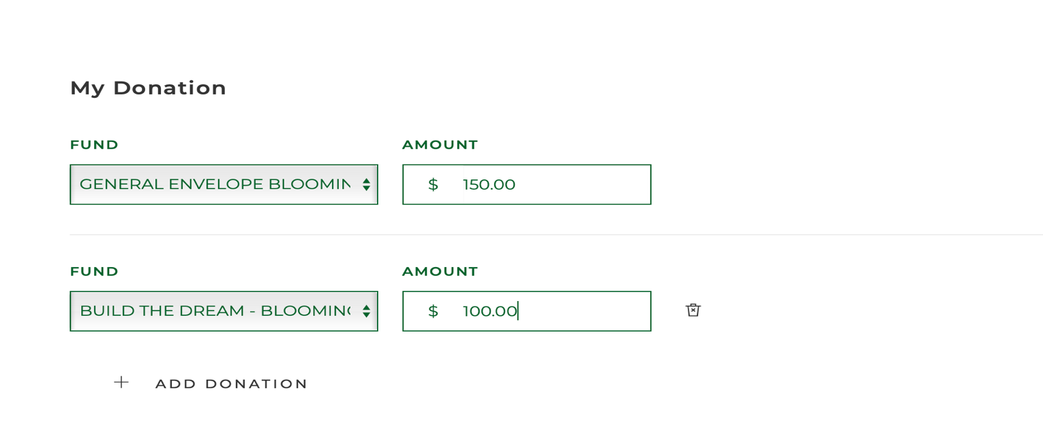

Step 9: Setting up the Recurring Details
- Scroll down to the “Recurring Gift Details” section of the page
- Select “FUND” and complete “Amount” for the additional donation category.

Step 10: Setting up the Recurring Details
- Scroll down to the “Recurring Gift Details” section of the page
- Click on the Frequency Box and Select the frequency of the Online Giving

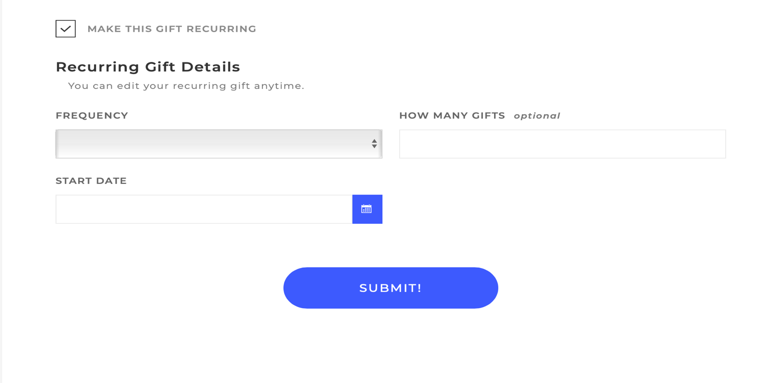

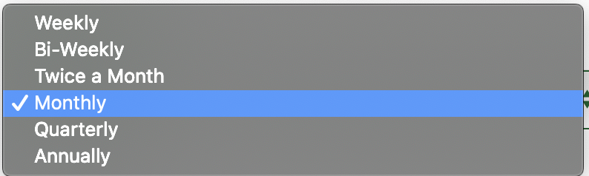

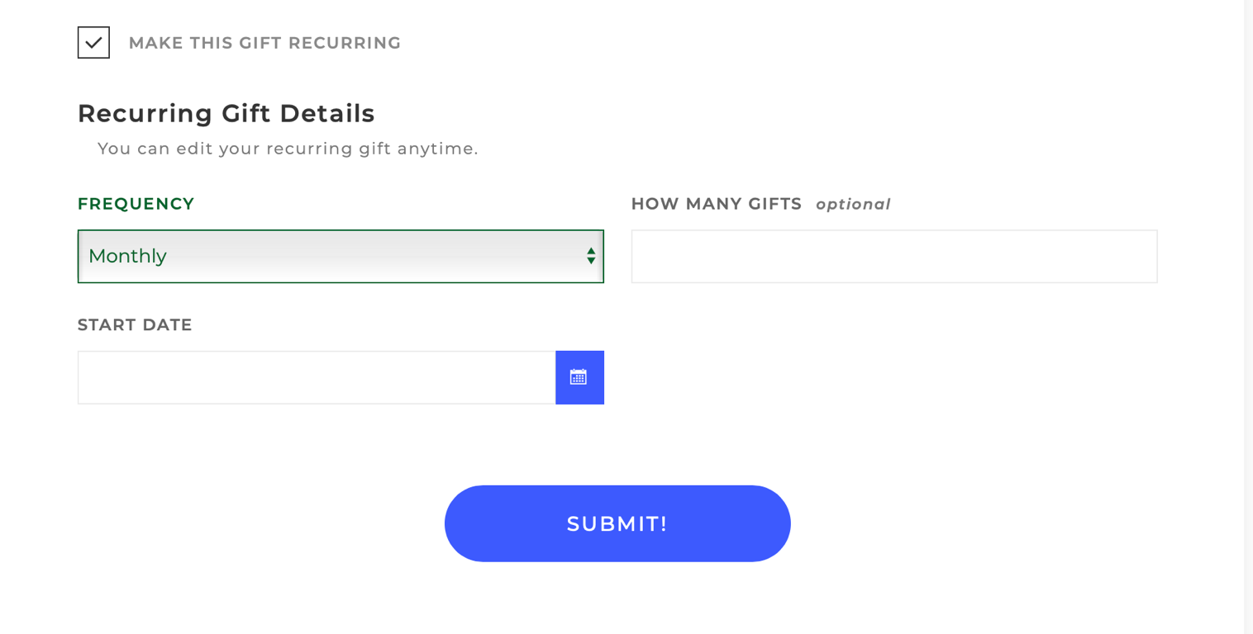

Step 11: Select the Start Date of your Recurring Online Giving
- Click the Menu Box on the right of the Start Date field
- Click on the Month / Date you would look like to start your giving (e.g. 3/31/2020)

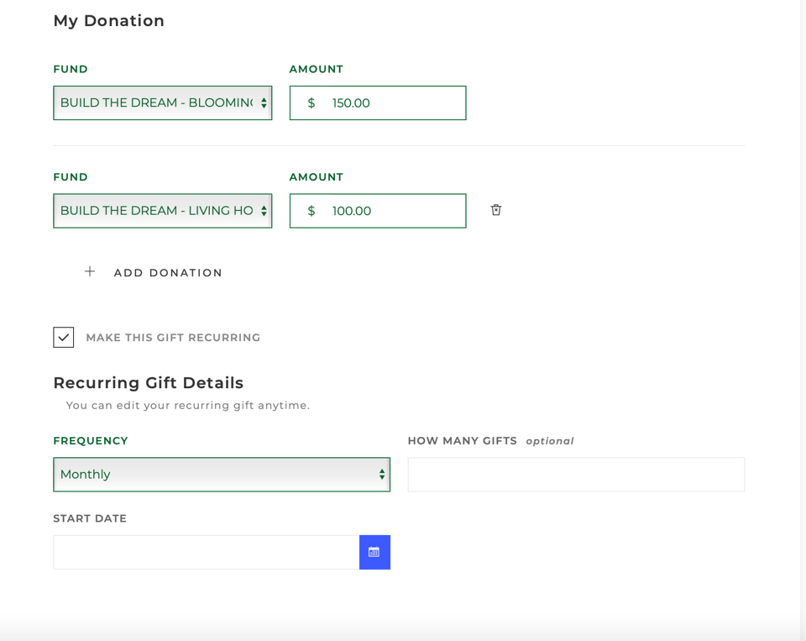

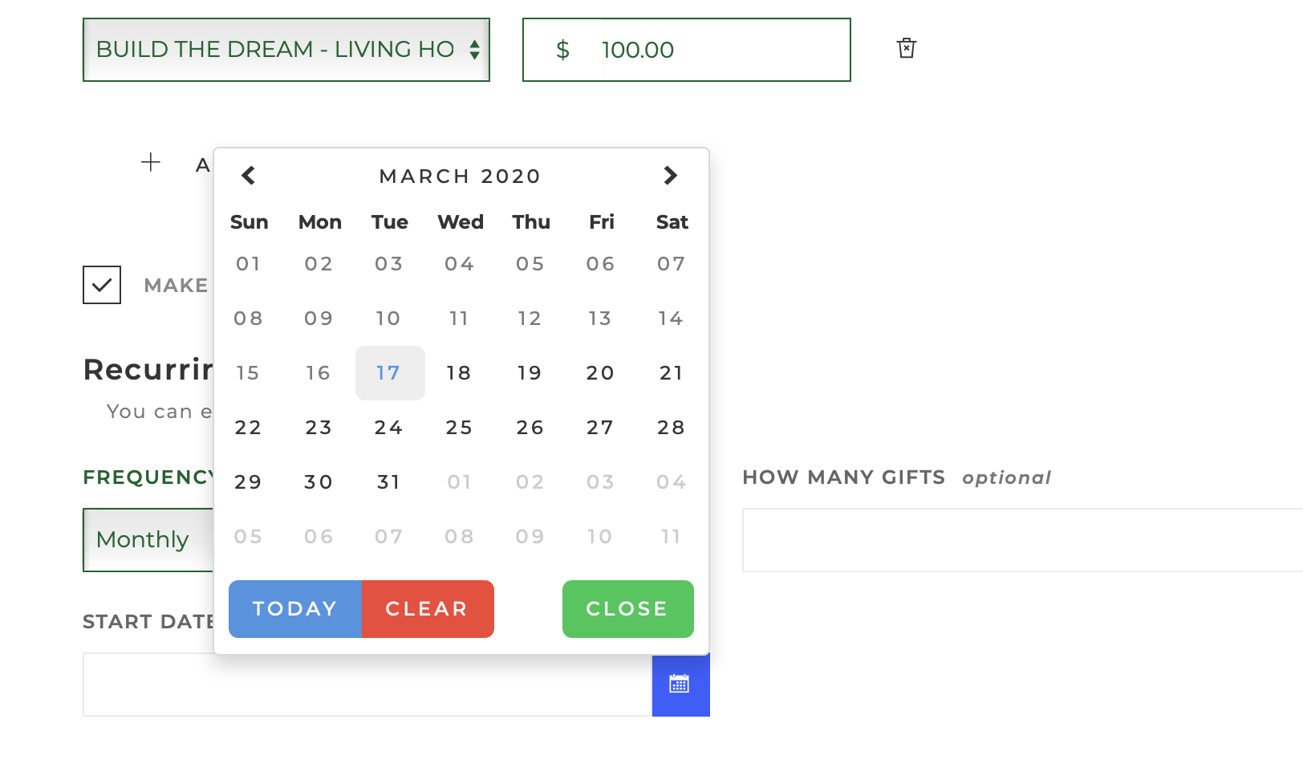

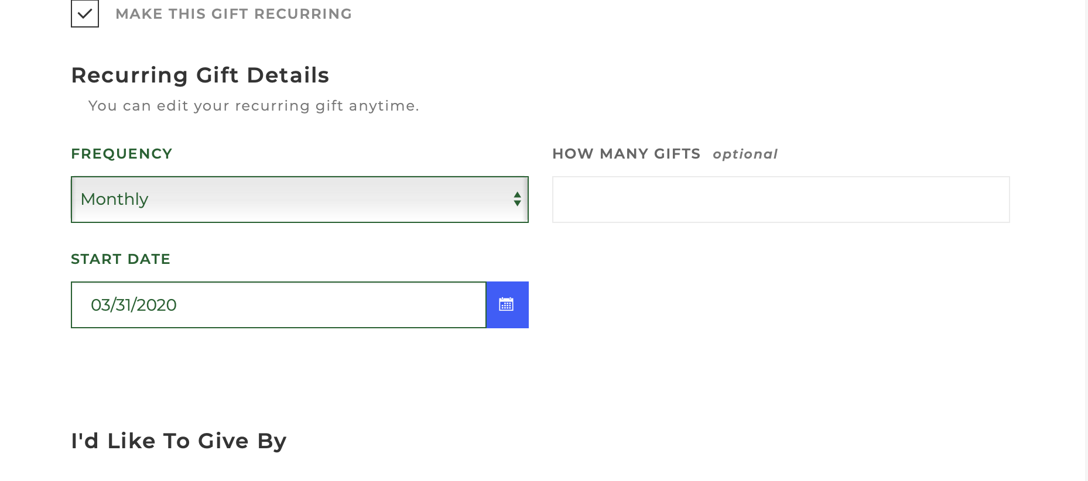
Step 12: Select your Payment Type
- Scroll down to the “I’d Like To Give By” section
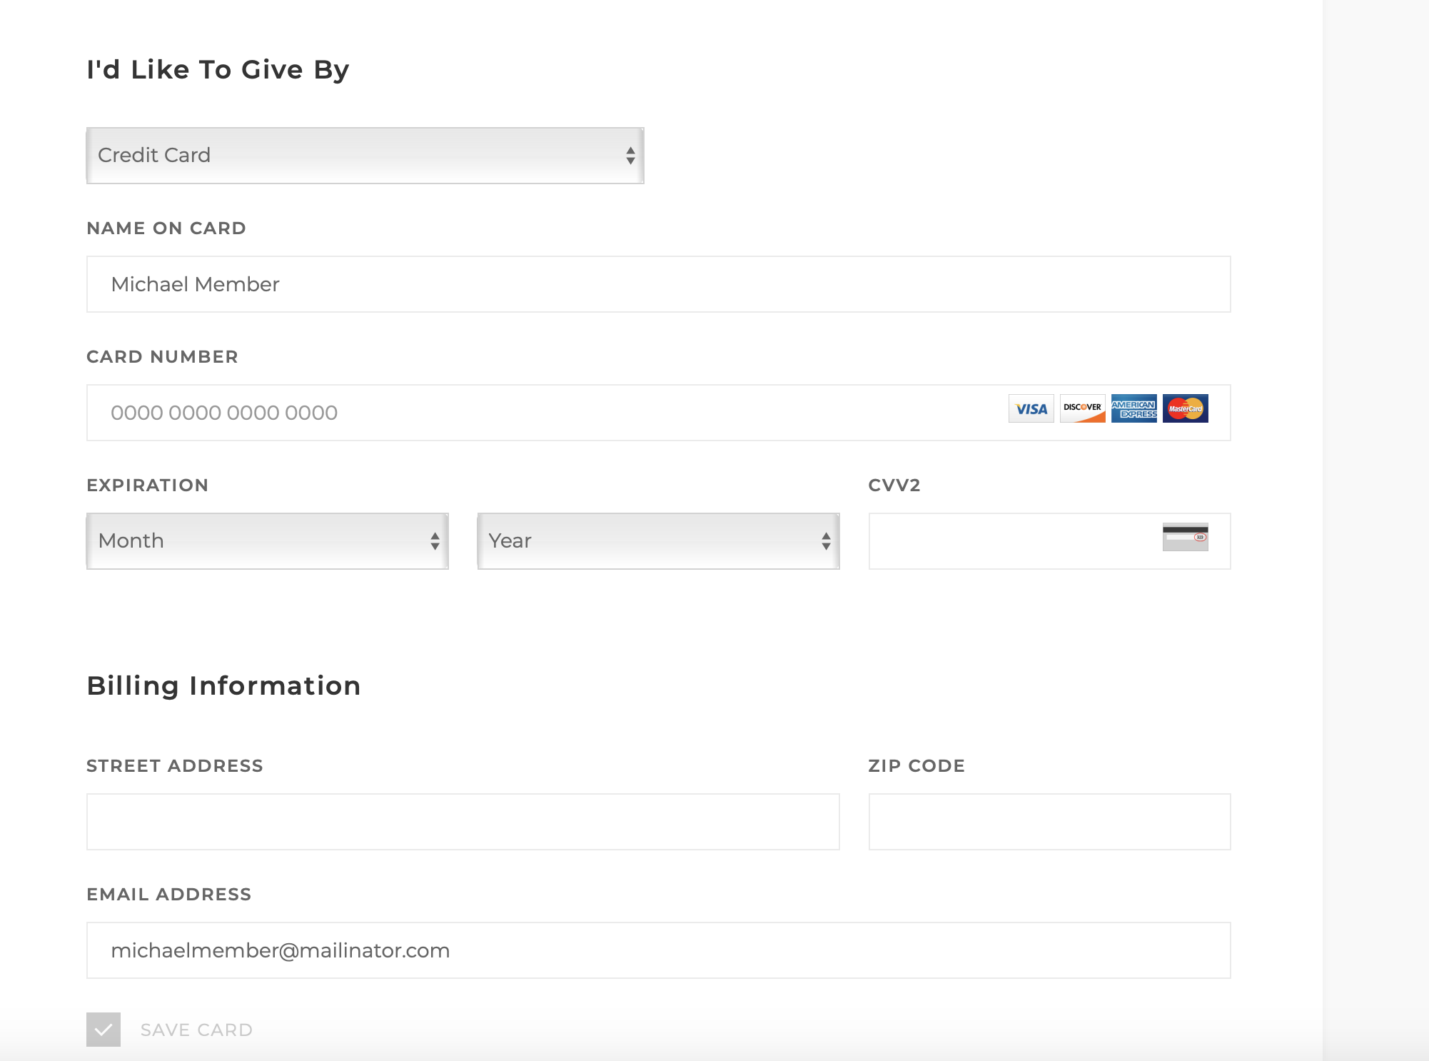

Step 13: Select <Credit Card> or <Bank Account> to set up your recurring giving
- Scroll down to the “I’d Like To Give By” section
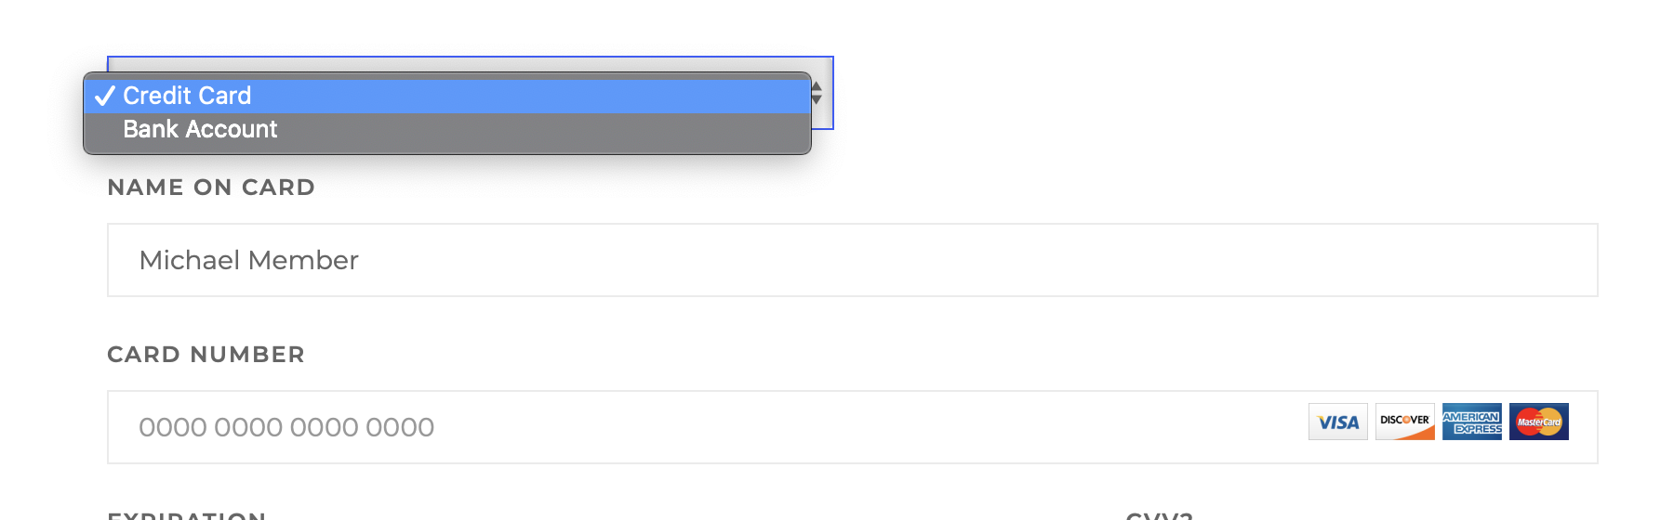

SETTING UP PAYMENT THROUGH YOUR CREDIT CARD

Step 14a: Credit Card Payment and Billing Information setup:
- Complete the Credit Card Setup section with all of the required information
- Complete the Billing Information section
    - Email address will be auto-filled with your profile email
  - Select “Save Card” if you want the system to automatically use this information for each of your recurring payments going forward.

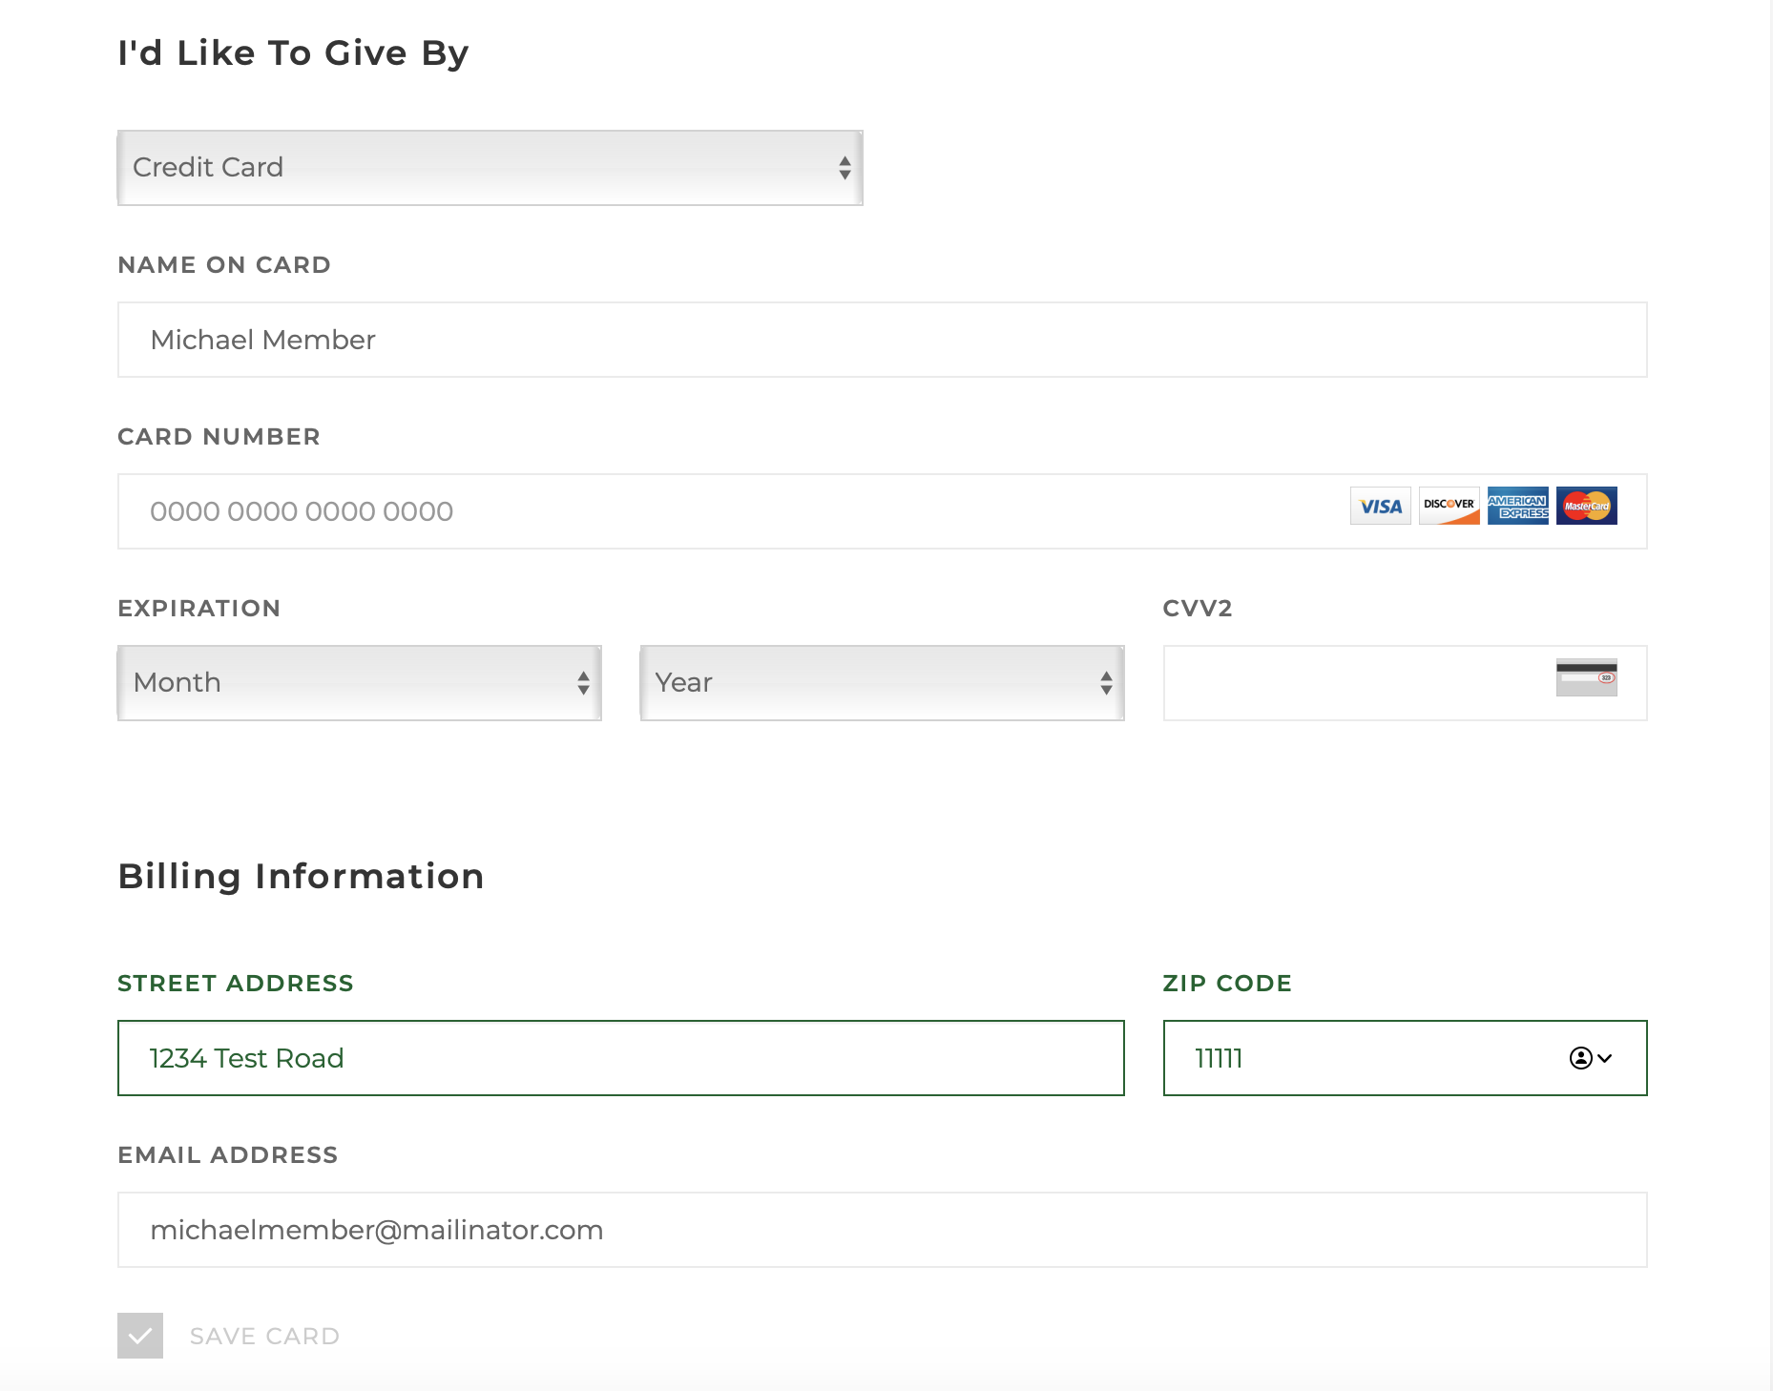

Step 15a: Submit your recurring giving
- Validate the dollar amount total
- Select “SUBMIT $$ Amount” button
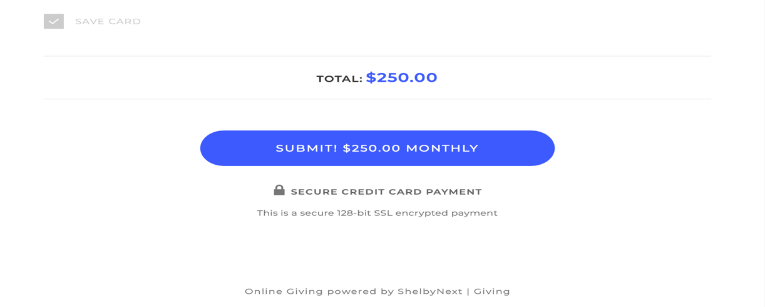
SETTING UP PAYMENT THROUGH YOUR BANK ACCOUNT

Step 14b: Bank Account Payment and Billing Information setup:
- Complete the Bank Account Setup section with all of the required information
- Complete the Billing Information section
    - Email address will be auto-filled with your profile email
  - Select “Save Account” if you want the system to automatically use this information for each of your recurring payments going forward.

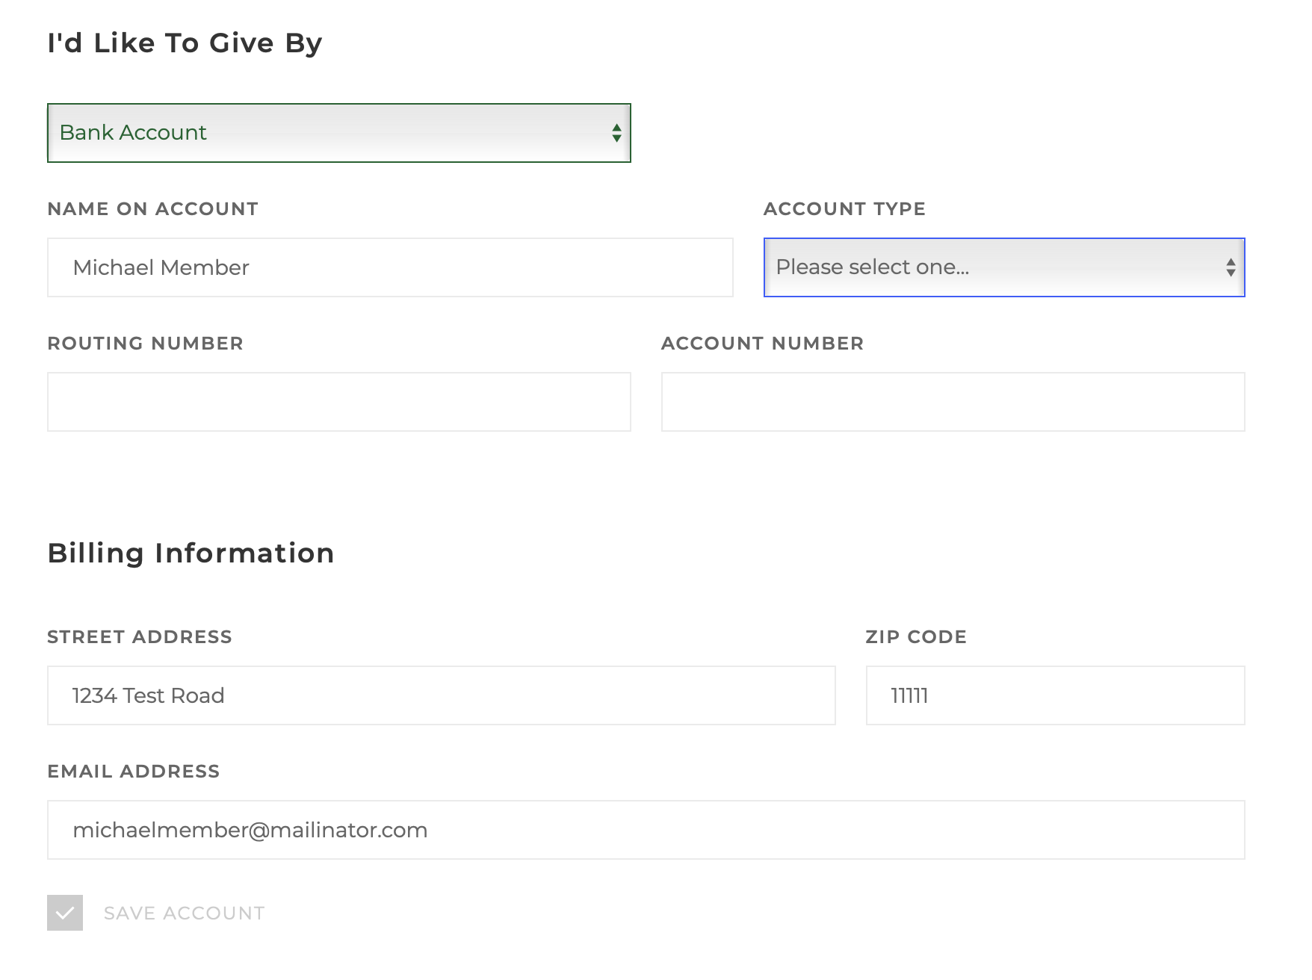

Step 15b: Submit your recurring giving
- Validate the dollar amount total
- Select “SUBMIT $$ Amount” button
