Instructions for Creating Ministry ID for Login

Note:
- Each MEMBER must create their own Ministry ID to link Membership and Giving functions together.
- This new MINISTRY ID will replace the original login and password you received from the church.
- Please make sure write down the your new MINISTRY ID in a safe place that you can refer to when you need it
- Whether you choose to use your COMPUTER or the Phone APP to access your membership information or to execute Online Giving, these MINISTRY ID steps should be followed first.

Example Family used for these instructions:
- Michael (Mike) Member - Primary Contact (Husband)

Step 1: Locate your original USERNAME and PASSWORD information
- Sent to you in email from church administration prior to “kickoff”
- Questions about this login information - please contact the church office.

Step 2: Log into ShelbyNext for Bloomington Living Hope Lutheran Church
- https://bloomingtonlivinghope.shelbynextchms.com

Step 3: Complete Login Screen
- Your USERNAME and PASSWORD into the login page
- Click <LOGIN>

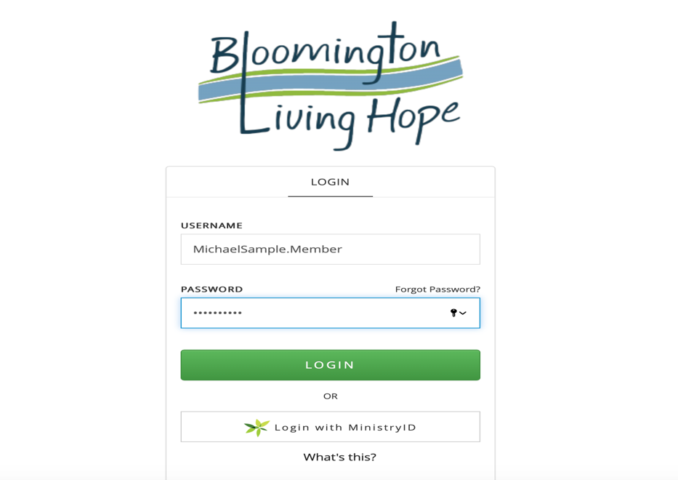

Step 4: Review your personal Profile page(s)

You will now be able to view and edit your profile and settings. Our sample Primary Contact is “Mike Member”
- Your Name will appear in the upper portion of the screen (where “Mike’s” name is showing in the below sample)
- Your Initials will appear in the upper right hand corner (where you see “MM” in the below sample)

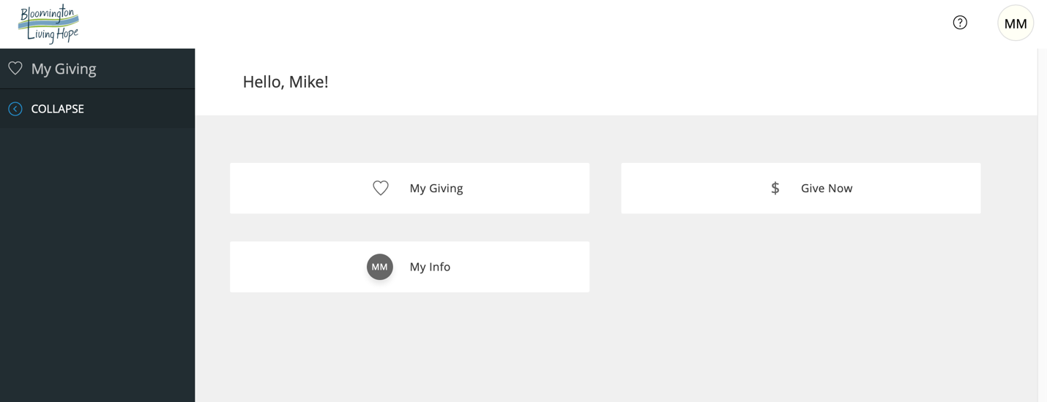

Step 5: Access your Profile information (including login) by clicking on either profile button:
- “My Info” box in the main screen
- Your “Initial Circle” in the upper right hand corner.

Step 6a: CRITICAL - Validate your Email Address is Accurate and EDIT it if needs to be updated:
- Locate the <Email> field on your “My Info” page
- Confirm it is accurate accurate
- If NOT accurate, follow the following instructions to update your Email Address. (6b - 6__)
- If ACCURATE, move to step

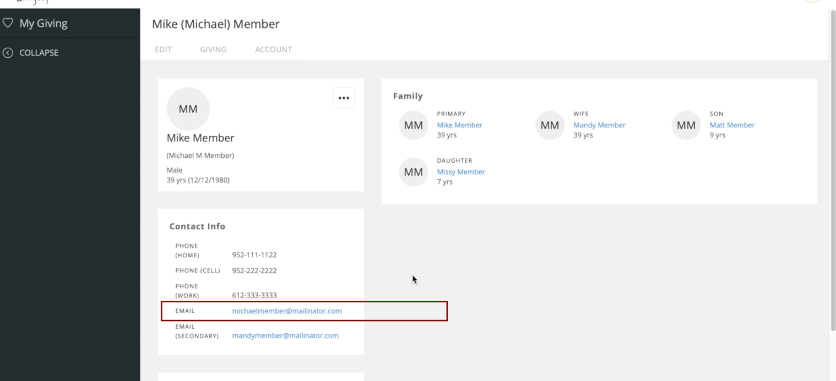

Step 6b: If Email needs to be updated:
- Scroll Up and click on the <EDIT> tab

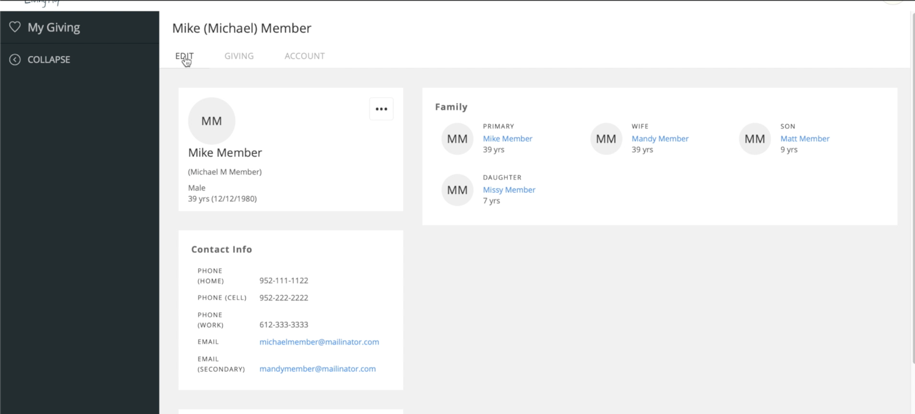

Step 6c: You are in your Profile Edit Screen - Update “Primary Email” field
- Find the “Primary Email” field
- Type in correct email
- Click on <SAVE> at the bottom of the page (see next three screen shots)

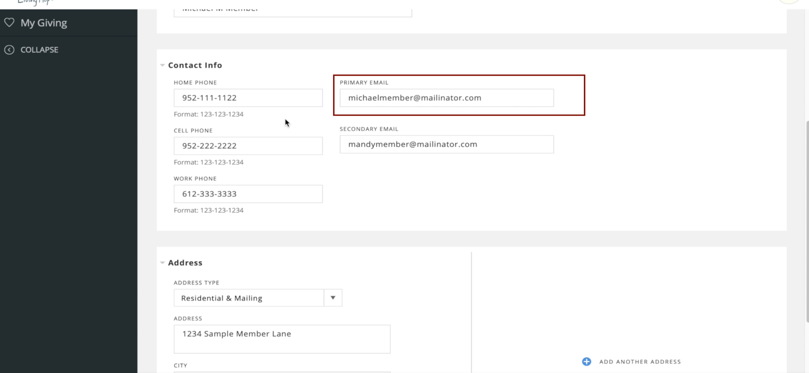
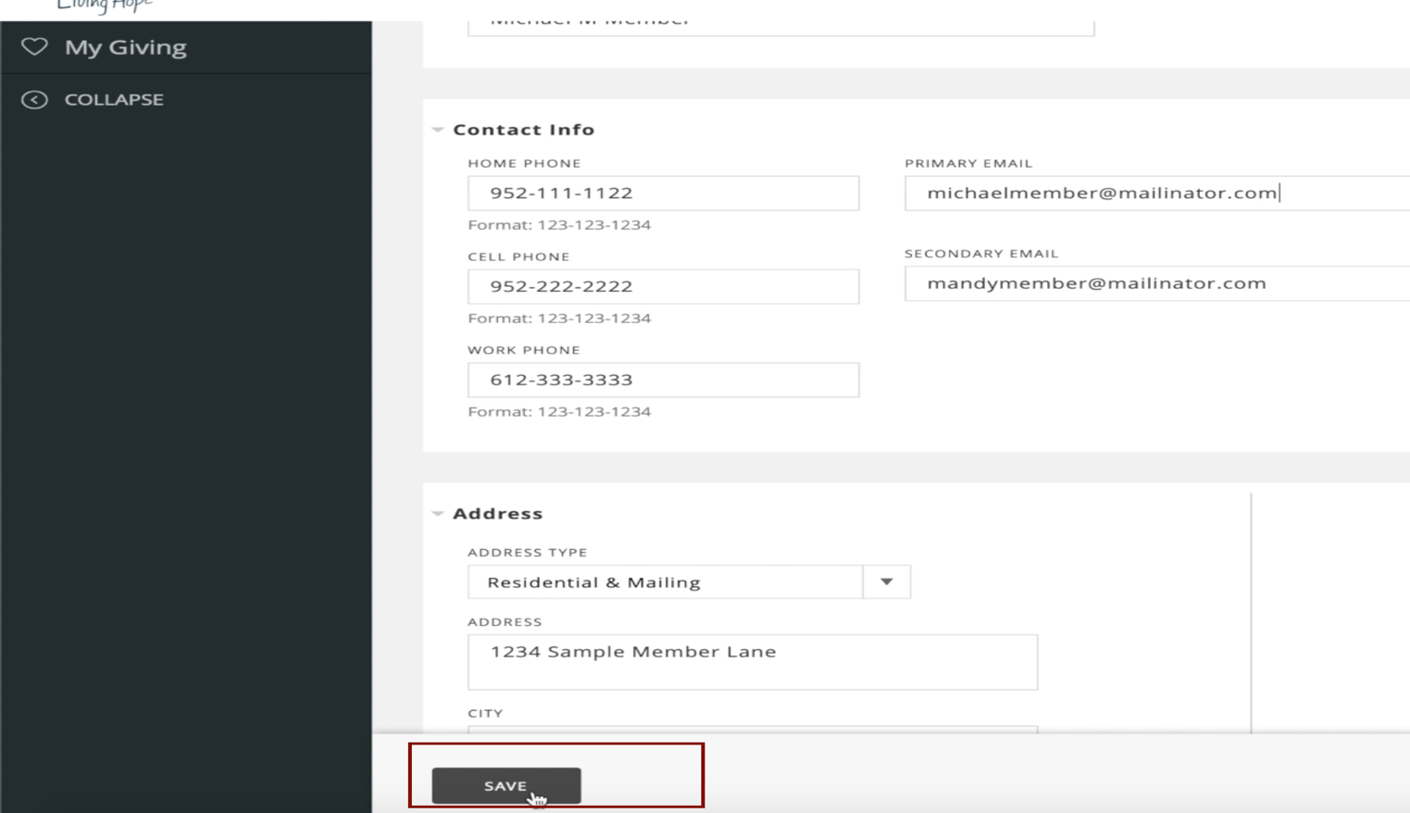

Step 6d: You’ll See Updated Profile message

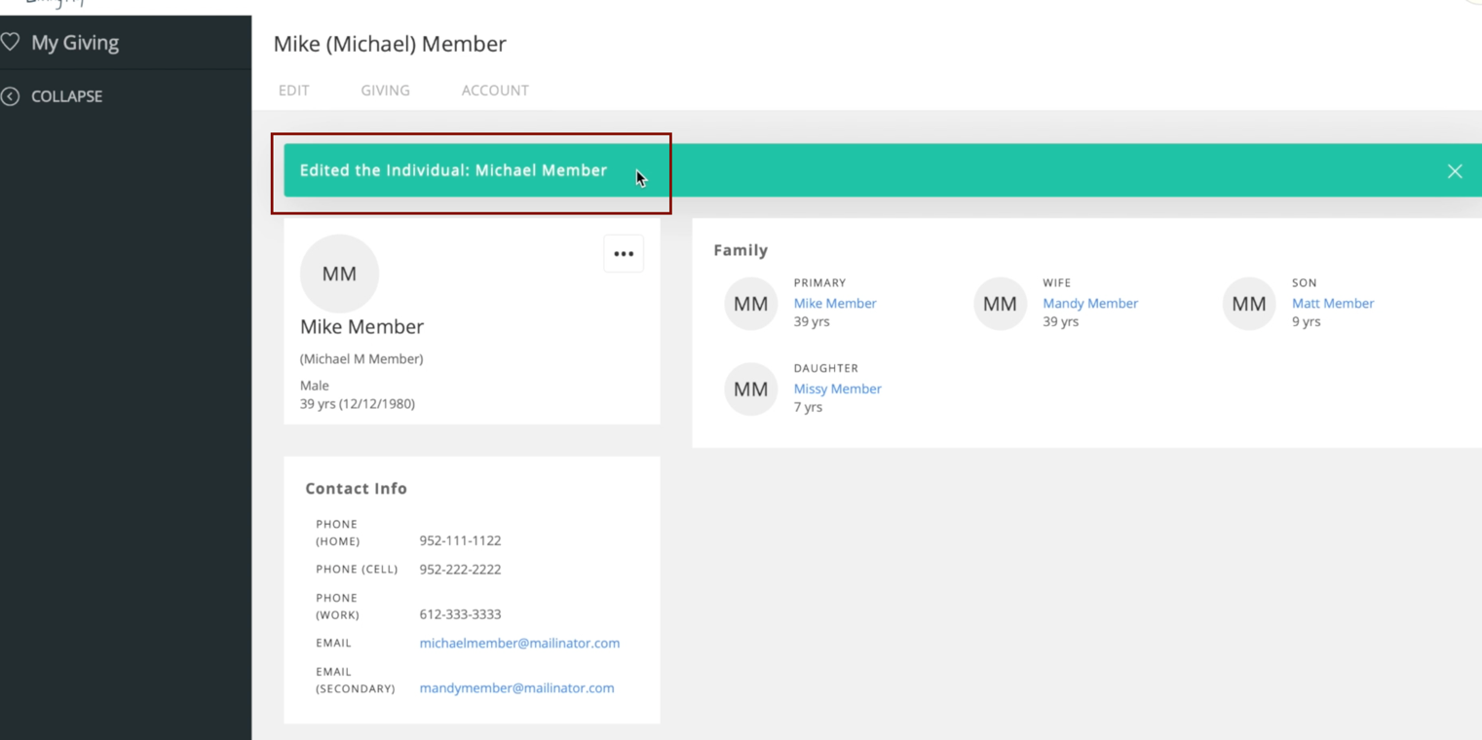

NOTE: Now you can go into your Account screen to create your MINISTRY ID.

Step 7: Go into the <ACCOUNT> tab
- Locate the <ACCOUNT> tab
- Click on the <ACCOUNT> tab

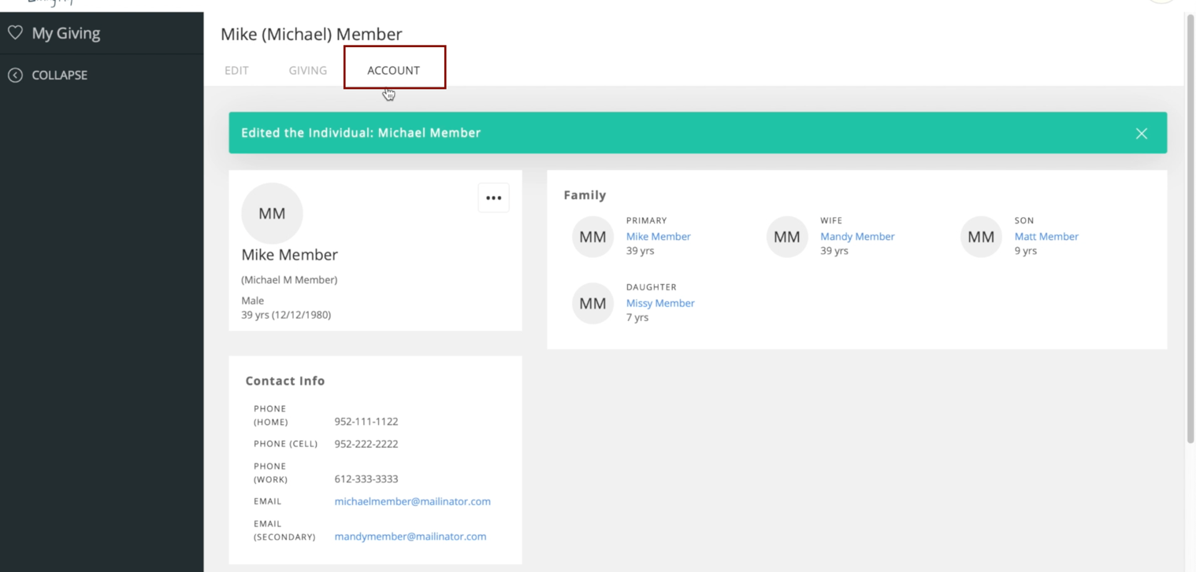

Step 8: Creating a MINISTRY ID
- Find the <Create MinistryID> box
- CLICK on <Create MinistryID>
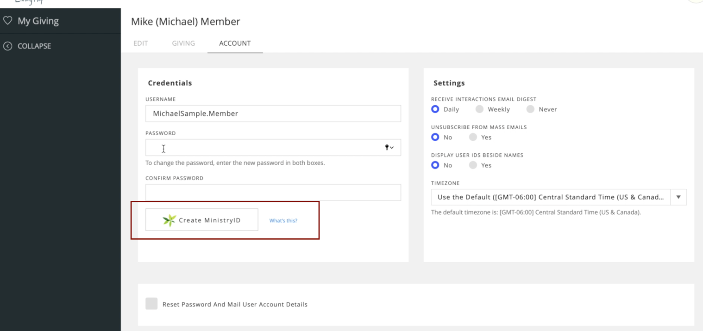

Step 9: Creating a New Ministry ID
- Because you do not yet have a Ministry ID, you need to Create One.
- Click on the <Create one> link on the bottom of the window

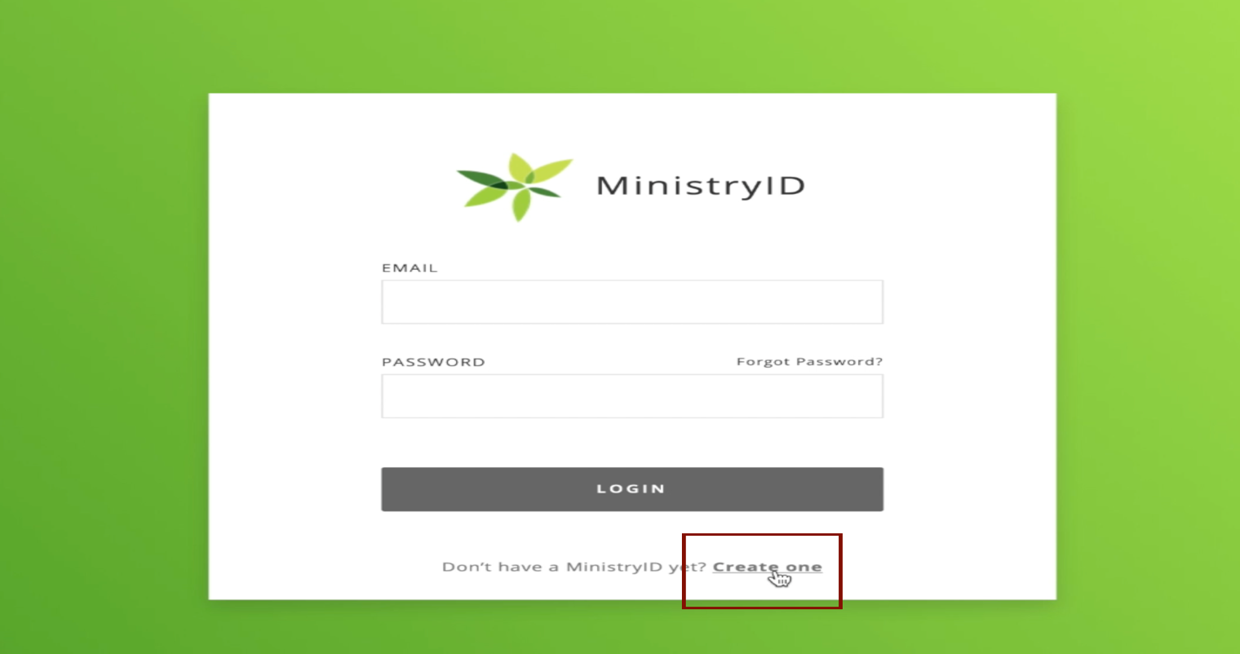

Step 10: Creating a “MINISTRY ID” - Email & New Password
- NOTE: This Ministry ID is what you will use going forward to access your Membership and Giving account on your computer or on the Phone App.
- Please write this Email / Password down in a safe place where you can refer to it later
- Complete the <EMAIL> field with the PRIMARY EMAIL you validated / updated on your membership profile screen earlier in Step 6.
- Type New Password in the <PASSWORD> and <CONFIRM PASSWORD> fields
  - 7 characters minimum
  - Must Include: Capital letters, Lowercase letters, at least one number
  - Example: AAbbCc194
- Click <SUBMIT>
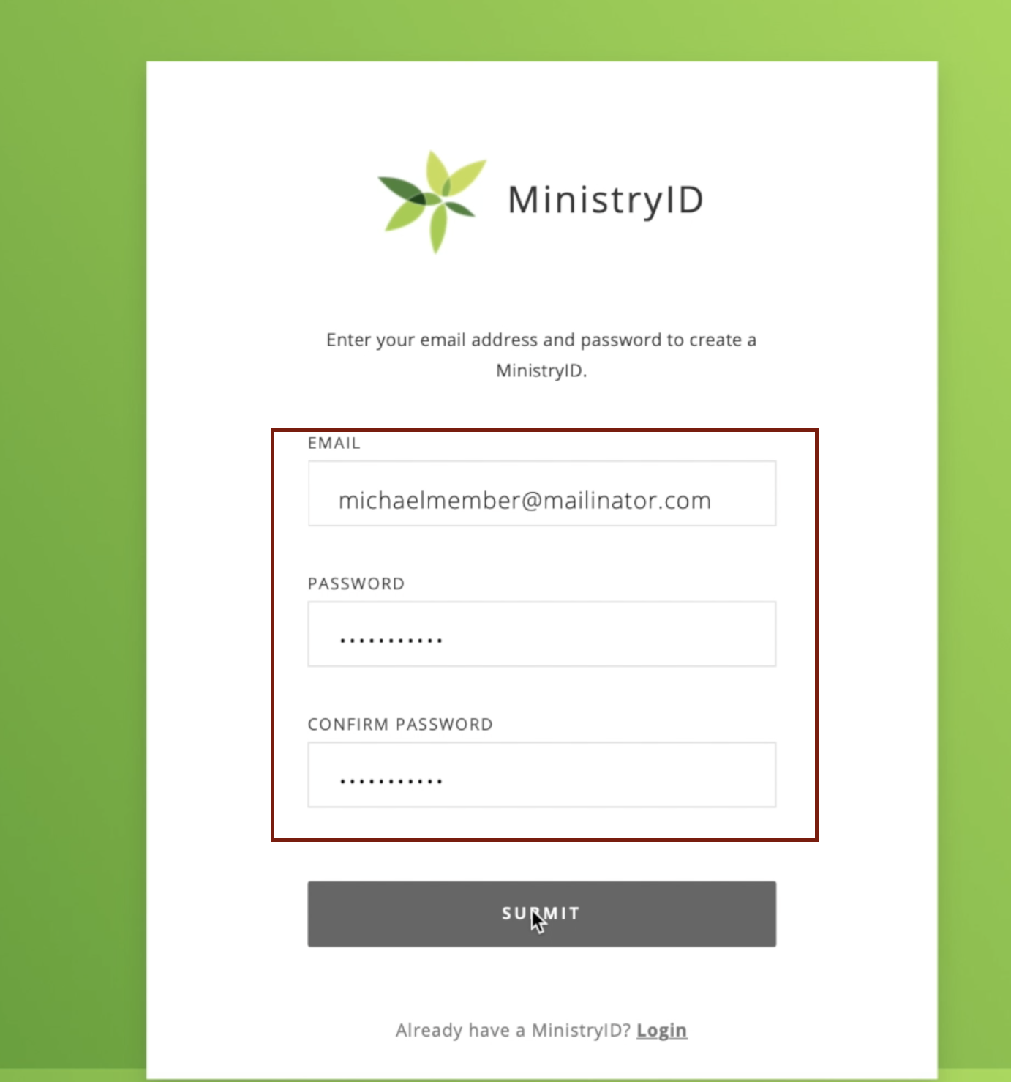

Step 10: You will see this message when your Ministry ID is set up
This Ministry ID (email & password that you just set up) is what you will use to log in going forward on both the computer or the phone app.
- Click <DONE> to close this window
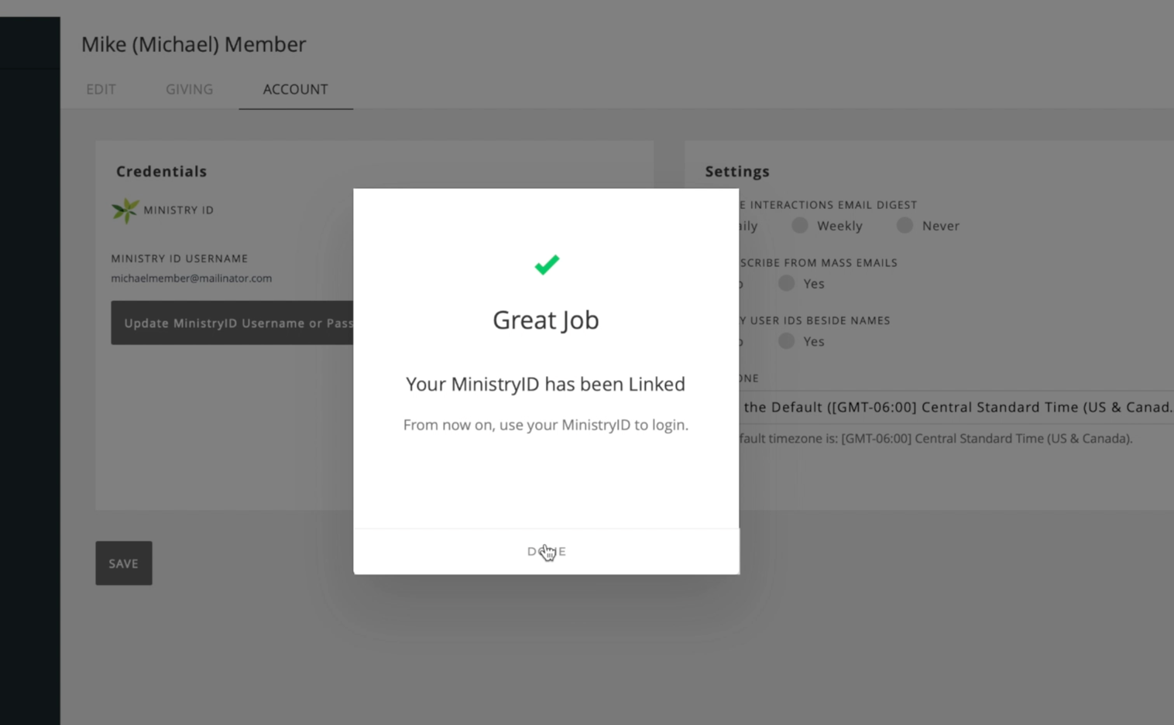

Step 11: You will see that your ACCOUNT information now shows your Ministry ID (instead of the original UserName and Password you were assigned).

- This Ministry ID (email & password that you just set up) is what you will use to log in going forward on both the computer or the phone app.
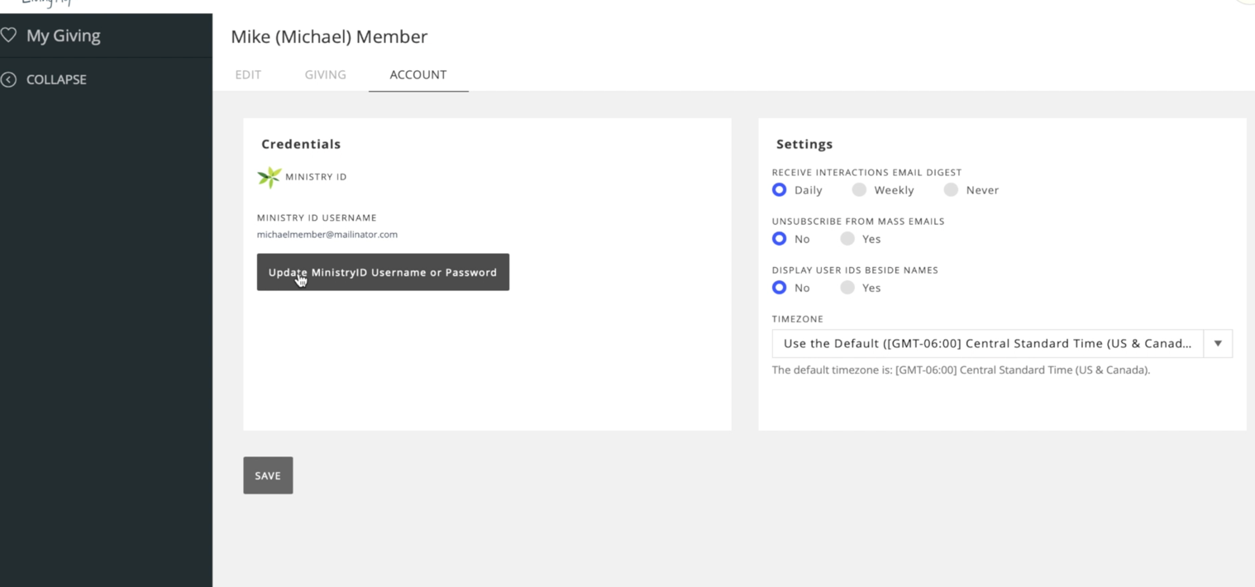
Step 11 NOTE: Changing your Ministry ID in the future
- If you need to change your Ministry ID in the future, please click on <Update Ministry ID Username and Password> and you can make those changes.
- These changes will take effect immediately.
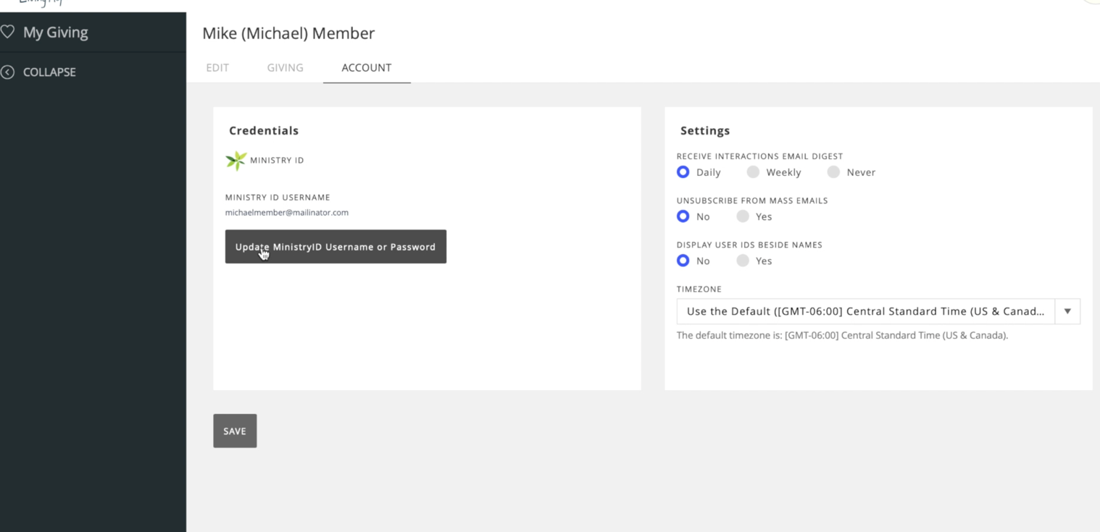
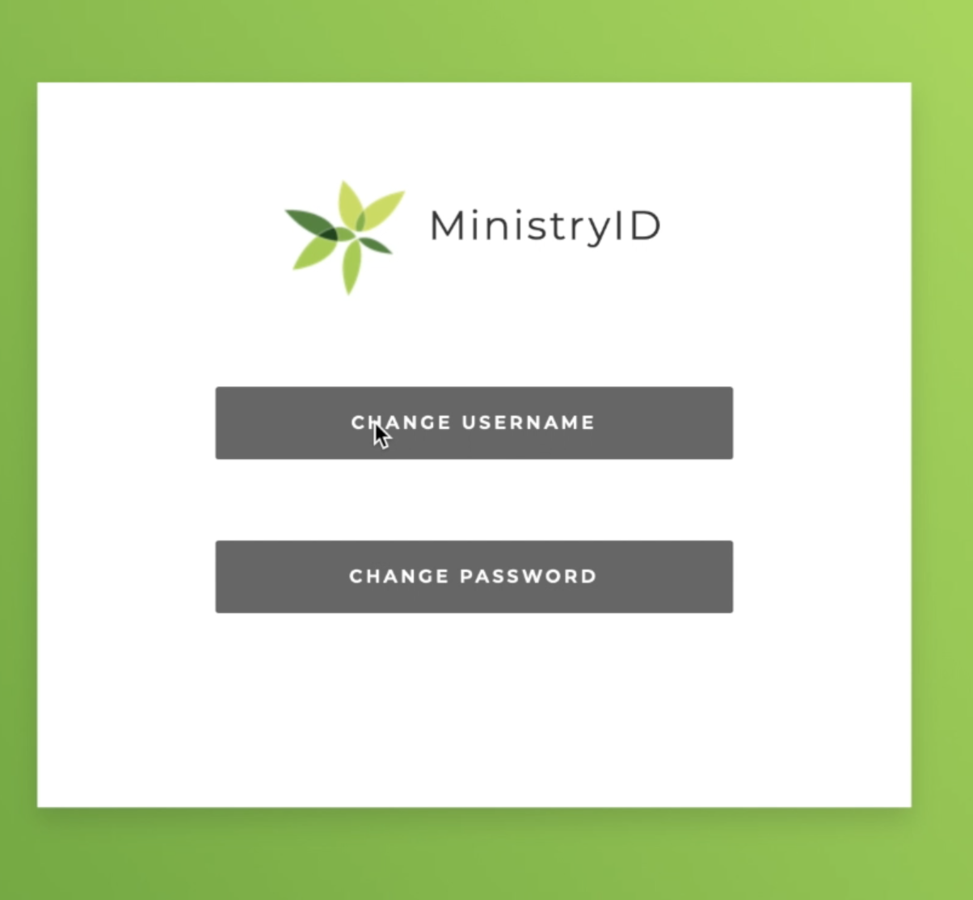

Step 12: Using Ministry ID to set up Giving Account and Features
- Now that your Ministry ID is set up, you will use it to set up your Giving Account and Features

Step 13: First Go back to your HOME Page
- Click on the “Bloomington Living Hope” logo at the top left corner of your web page.
- You will be directed back to your membership home page.

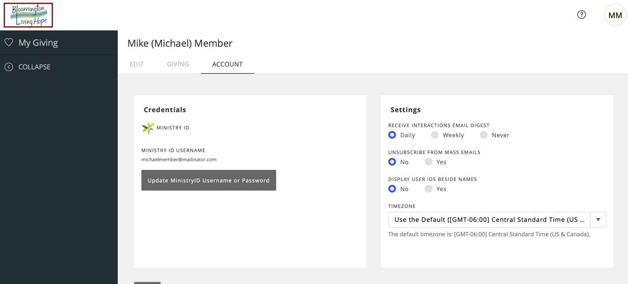

Step 14: Click on the <$ Give Now> box
- You are now being directed to the Giving features of ShelbyNext
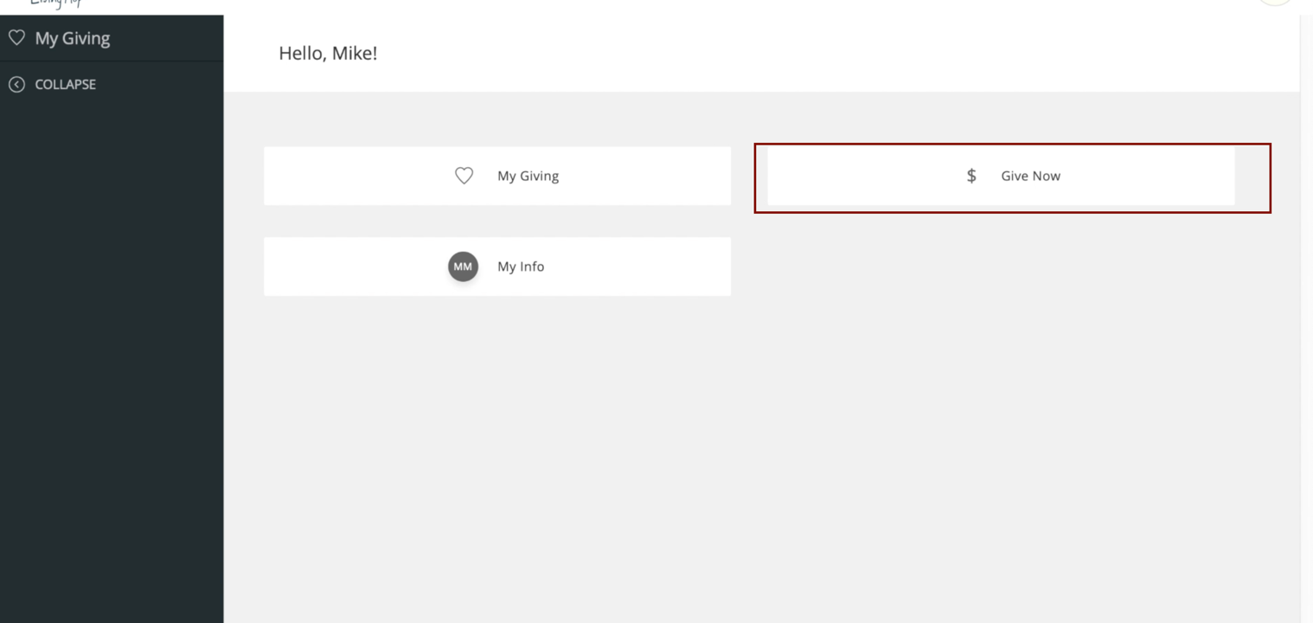

Step 15: Click on the <$ Give Now> box
- You are now at the “Giving Page”
- This is the page where you can set up your information for
  - One Time Giving
  - Recurring Giving
  - These instructions will be covered later

Step 16: Click the RECURRING box (to get into Giving Setup).
- Click the box next to “MAKE THIS GIFT RECURRING”
- This will not set up any recurring giving (covered later in this document)
- You will be navigated to a Giving Account Setup / Login

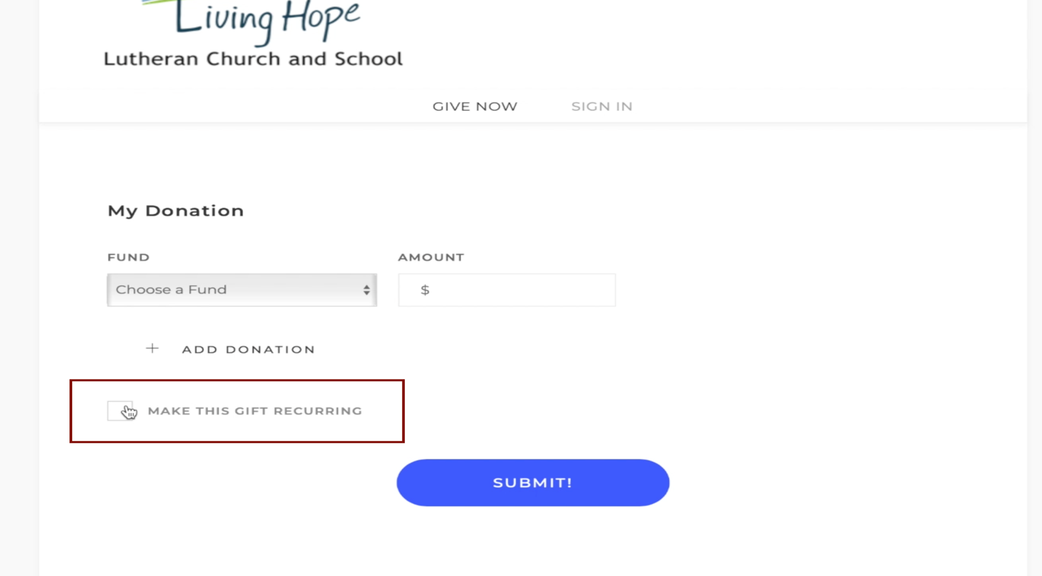

Step 17: In the next screen, click on LOGIN WITH MINISTRY ID
- Click on the <LOGIN WITH MINISTRY ID> box

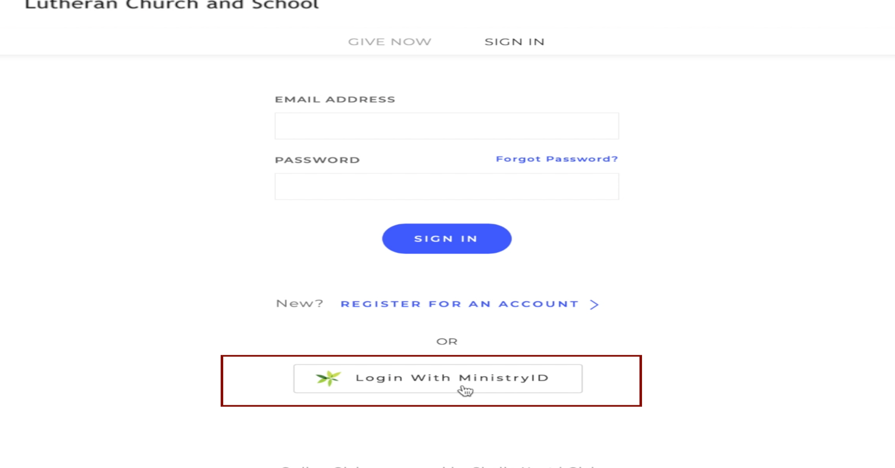

Step 18: Log Into Giving Features with Ministry ID
- EMAIL: Type in your Ministry ID Email (your email address)
- PASSWORD: Type in your Ministry ID Password (you created previously)
- Select <LOGIN>
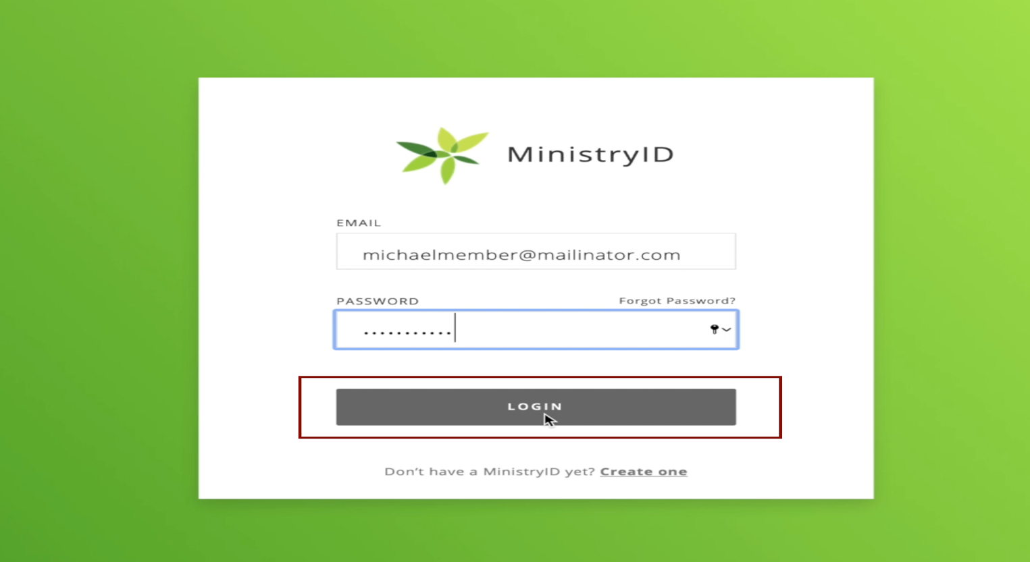

Step 19: Creating a GIVING account using your Ministry ID
- Select <CREATE AN ACCOUNT>

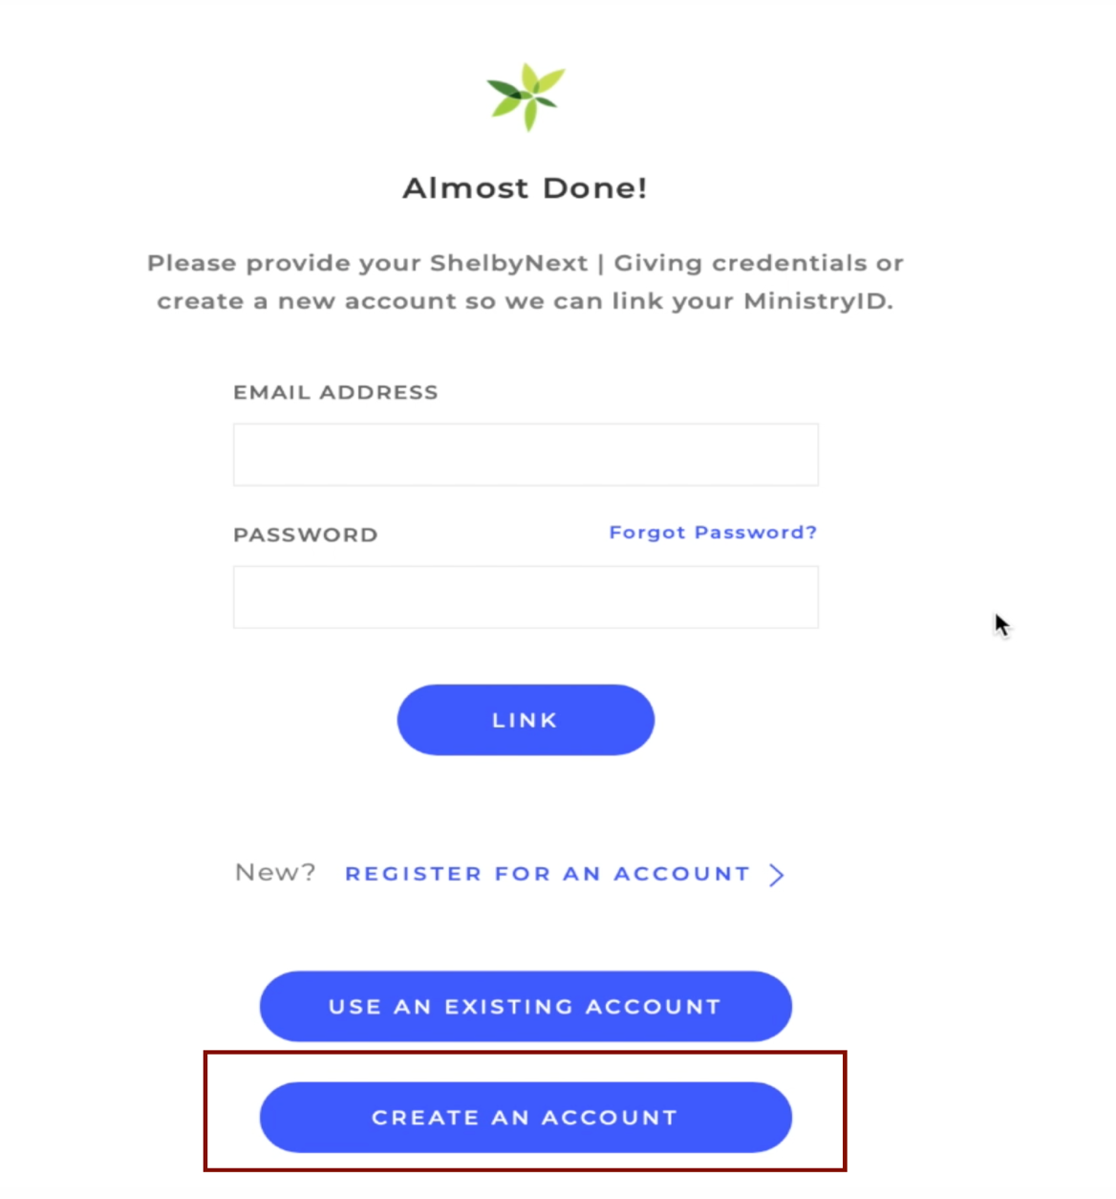

Step 20: Giving features Setup (Almost Done!)
- First Name: Type in your first name
- Last Name: Type in your last name
- Email Address: Type in the SAME email address on your profile that you used for your MINISTRY ID Email. Please check for accuracy.
- Click on <NEXT>
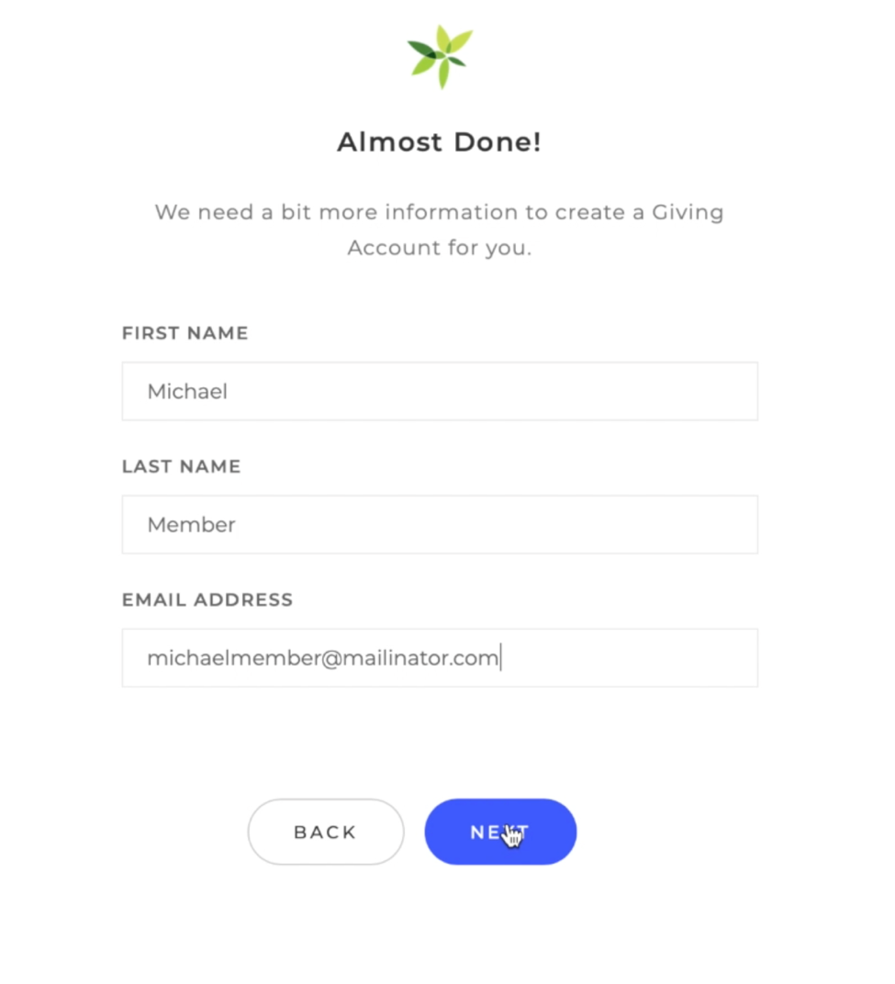

Step 21: Confirmation Screen [Giving Account Set Up and linked to your Ministry ID]
- Giving account is now set up and your Ministry ID can be used to access your full set of account features
- Click <DONE> to close window

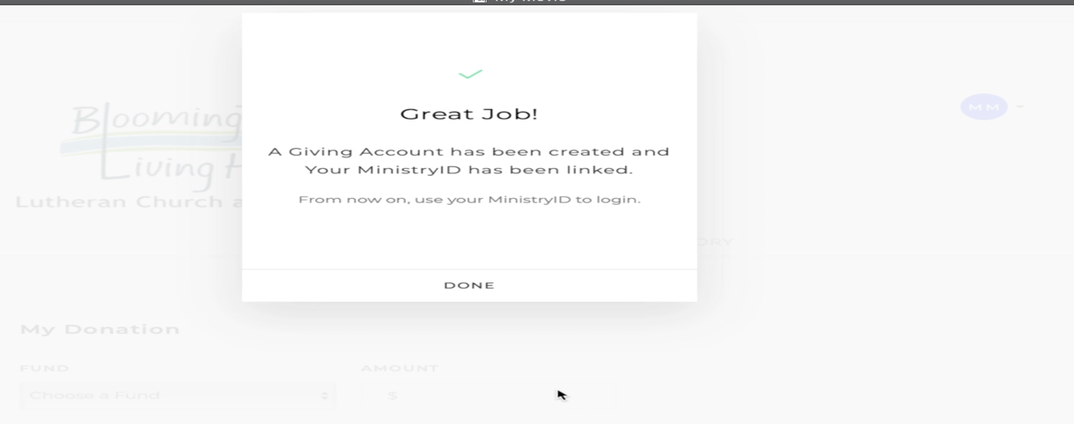

Step 22: Giving Screen ($ Give Now) features - See Later Giving Setup Steps
- Now everything is set up for you to create your online giving
- See “Online Giving” setup steps later in this document.

Going Forward: Logging into your account
- Now Ministry ID is set up for all of your account features
- You will use this Ministry ID to log into ShelbyNext (Computer and Phone App)
- Always select <Login with MinistryID>
- Use your Ministry ID (Email + Password)

